

Program: Post Graduate Diploma (PGD) in Data Science
Course Title: Data Science Project
Course: PGDDS 203
Project Title: Rainfall Prediction in Bangladesh Using Machine Learning: An Analysis of Meteorological Data
Final Report
Submitted by:
Student Name | ID
Md. Sahariar Sahen | 905253005
Mohammad Shahinur Tarek Mahmud | 905253009
Md Habibur Rahaman | 905253019
MD. Shafiqul Islam | 905253024

Submitted to:
Ahmed Imran Kabir,
Assistant Professor
School of Business & Economics (SoBE)
United International University (UIU)
Dhaka, Bangladesh.

Executive Summary
Accurate rainfall prediction is important for agricultural planning, water-resource management, flood preparedness, and climate-related decision-making in Bangladesh. This study developed a machine learning framework to predict next-day rainfall using rainfall observations from 34 Bangladesh Meteorological Department (BMD) stations along with meteorological data from NASA POWER for the period 1984–2016. Following data integration and quality assessment, the final dataset consisted of 397,902 daily observations and 20 variables. Exploratory analysis found that 67.84% of the observations were dry days, while rainfall showed a strong right-skewed distribution (skewness = 5.76). Rainfall recorded on the previous day showed the strongest relationship with next-day rainfall (r = 0.393), suggesting a clear persistence effect. In addition, the first three principal components accounted for 83.3% of the total variance in the meteorological variables.
A Logistic Regression model was first used as a baseline for predicting next-day rainfall occurrence. It achieved an F1-score of 0.759 and a recall of 0.881. For predicting rainfall amount, nine approaches were evaluated using a chronological test period covering 2012–2016. These included naive baselines, Linear Regression, SARIMA, Random Forest, LSTM, back-propagation neural network, standard XGBoost, and XGBoost with a Tweedie objective. The final Tweedie-XGBoost model, using a variance power of 1.3, achieved an RMSE of 14.26 mm, MAE of 5.76 mm, and R² of 0.427, compared with an R² of 0.143 for the seasonal climatology baseline. Cloud amount was identified as the most influential predictor, followed by regional rainfall, surface shortwave radiation, and dew point temperature. An additional experiment using NASA POWER precipitation as the target resulted in a lower R² of 0.272, supporting the use of BMD observations as the ground-truth rainfall data.
Overall, the results show that a nationally integrated, station-level machine learning framework can capture meaningful patterns in next-day rainfall across Bangladesh. However, prediction performance remains limited by the relatively coarse spatial resolution of NASA POWER data and the difficulty of representing highly localized extreme rainfall events.

Table of Contents
1. Introduction and Problem Statement 7
2. Background and Literature Review 8
3. Dataset Description 9
3.1. Data Sources 9
3.2. Bangladesh Meteorological Department (BMD) 9
3.3. NASA POWER 9
3.4. Dataset Coverage 9
3.5. Data Acquisition & Initial Load 10
3.6. Data Dictionary 11
3.7. Target Variable 12
3.8. Data Preprocessing 12
3.9. Dataset Suitability 12
4. Missing Value Treatment 13
5. Outlier Detection & Treatment 14
6. Duplicate Records 15
7. Data Encoding, Labeling & Feature Extraction 15
7.1. Encoding 15
7.2. Feature Extraction / Engineering 16
7.3. Feature Scaling 17
8. Dimensionality Reduction (PCA) 17
9. Final Cleaned Dataset Summary 19
10. Descriptive Statistics and Visualization 20
10.1. Rainfall (Target Variable) 20
10.2. Correlation Analysis 21
10.2.1. Rainfall's Strongest Relationships 21
10.2.2. Relationships Among Weather Features 22
10.3. Exploratory Data Analysis 23
10.3.1. Exploratory Analysis of Daily Rainfall 23
10.3.2. Distribution of Rainfall Amount on Rainy Days Only 24
10.3.3. Regional Variation in Rainfall 25
10.3.4. Distribution and Relationships Among Meteorological Features 26
10.3.5. Relationship Between Relative Humidity and Rainfall 28
10.3.6. Regional Variation in Rainfall Occurrence 29
10.3.7. Monthly Seasonality of Rainfall and Temperature 30
10.3.8. Seasonal and Regional Variation in Rainfall Occurrence 31
11. Patterns, Trends & Anomalies 32
11.1. National Monthly Rainfall Trend 33
11.2. National Annual Rainfall Trend 33
11.3. Multivariate Anomaly Detection 34
12. Preliminary Modeling 36
12.1. Logistic Regression Model Results and Interpretation 36
12.2. Class Distribution and Model Performance 36
12.3. Interpretation of Feature Coefficients 37
12.4. Confusion Matrix Analysis 39
12.5. Overall Interpretation 39
13. Rainfall Amount Regression and Final Model 40
13.1. Setup 40
13.2. Model Comparison 41
13.3. Rationale for Each Candidate Model 42
13.4. Final Model: XGBoost with a Tweedie Objective 44
13.5. Additional Experiments and Robustness Checks 46
13.6. Summary of Findings 48
14. Limitations 48

List of Figures
Figure 1: Boxplots of Surface Pressure (PS) and Wind Speed at 2 m (WS2M) with IQR-Based Outlier Fences. 15
Figure 2: Scree Plot of Principal Component Analysis (PCA) for NASA POWER Weather Features 18
Figure 3: PCA 2D Projection of Standardized NASA POWER Weather Features by Rainfall Occurrence. 19
Figure 4: Pearson Correlation Heatmap of Meteorological, Temporal, and Rainfall-Related Features 23
Figure 5: Distribution of Daily Rainfall in the Analysis-Ready Dataset. 24
Figure 6: Distribution of Daily Rainfall Amounts on Rainy Days Using a Log(1 + Rainfall) Transformation 25
Figure 7: Regional Distribution of Daily Rainfall Across Four Geographic Regions 26
Figure 8: Distribution of NASA POWER Weather Features. 27
Figure 9: Relationship Between Relative Humidity and Daily Rainfall Occurrence and Amount. 29
Figure 10: Regional Variation in Rainy-Day Frequency (%). 30
Figure 11: Seasonal Variation in Mean Monthly Rainfall and Temperature. 31
Figure 12: Seasonal and Regional Variation in Rainy-Day Frequency. 32
Figure 13: National Monthly Rainfall Trend with 3-Month Rolling Average, 1984–2016. 33
Figure 14: National Annual Rainfall Trend, 1984–2016. 34
Figure 15: Multivariate Weather Anomaly Detection Using Isolation Forest 35
Figure 16: Distribution of Rainy and Non-Rainy Days in the Dataset 37
Figure 17: Logistic Regression Coefficients for Rainfall Occurrence Prediction 38
Figure 18: Confusion Matrix of the Logistic Regression Rainfall Occurrence Classifier 39
Figure 19: Model Comparison by RMSE and R² on the 2012–2016 Test Period 42
Figure 20: Actual versus Predicted Next-Day Rainfall at the Best-Predicted (Teknaf) and Worst-Predicted (Bogra) Stations, Monsoon 2015 45
Figure 21: Calibration of Predicted Rainfall by Observed Intensity Bin and Density of Predictions, 2012–2016 Test Period 45

List of Tables
Table 1: Dataset Sources 9
Table 2: Dataset Description 10
Table 3: Dataset description 11
Table 4: Characteristics of the dataset 13
Table 5: Outlier detection and decision in the dataset 14
Table 6: Summary of feature extraction 16
Table 7: Comparison of the dataset before and after processing 19
Table 8: Descriptive statistics of the rainfall 20
Table 9: Correlation analysis coefficient (r) value 22
Table 10: Test-Period Performance of All Regression Models (2012–2016) 41
Table 11: Rationale, Strengths, and Limitations of Each Candidate Model 43
Table 12: Tweedie Variance-Power Sweep on the 2012–2016 Test Period 44

Introduction and Problem Statement
Bangladesh is one of the most climate vulnerable countries in the world where rainfall is playing a critical role in agriculture, water resource management, flood control, and overall socioeconomic development. The climate of the country is tropical monsoon climate with almost 70-80% of the annual rainfall received during the monsoon season (June to September). But in recent years, the rainfall has become more erratic, as a result of climate variability and climate change. These changes have led to erratic intensity of rainfall, delayed or early onset of monsoon, extended dry spells, flash floods and extreme weather events. The variability poses great difficulties to agriculture, irrigation planning, reservoir operation, urban drainage systems and disaster risk management.
Bangladesh is an agricultural country and a large number of people rely on agriculture for their livelihood and food security. Precipitation timing, intensity and distribution during the growing season is of great importance to the success of agricultural production. Rainfall is also necessary at the right time to prepare the land, to germinate seeds, to grow crops, and to manage irrigation, while too little or too much rainfall can have a significant impact on crop production. Furthermore, the irregularity of the rains at the end of the crop season or just before harvest can lead to significant losses in standing crops, grain quality, harvest delays and losses after harvest. This sudden rainfall has not only impacted farmers' livelihoods but also poses a risk to the country's food security and economic stability. Hence, the improvement of rainfall prediction is a crucial issue to reduce the risk in agriculture and promote sustainable agriculture in Bangladesh.
Precise rainfall forecasting is crucial for the timely decision making of farmers, government, water resource managers, and disaster management agencies. Accurate predictions can enable farmers to plan for optimal planting and harvesting dates and help policy makers better manage water resources, as well as help disaster management organizations prepare for flood, landslide and other rainfall-induced hazards. In contrast, conventional rain forecasting techniques, such as statistical and physical models, have difficulties in accounting for the complex and nonlinear nature of the meteorological variables and hence the accuracy of the forecasts is limited, especially in the face of changing climatic conditions.
In recent years, machine learning has shown great promise in enhancing weather and rainfall forecasting through its ability to learn complex patterns from past data. By analysing vast amounts of meteorological observations, machine learning algorithms can automatically discover hidden relationships between rainfall and other factors like temperature, humidity, atmospheric pressure, wind speed and the duration of sunshine. These data-driven methods can make more accurate and robust predictions than traditional methods, with fewer assumptions about the underlying data distribution.
Therefore, this project proposes the development of a machine learning-based rainfall prediction model using historical meteorological data collected from the Bangladesh Meteorological Department (BMD) and NASA POWER. The study will preprocess and analyze the historical weather dataset, engineer relevant features, and develop multiple regression models, including Linear Regression, Random Forest Regressor, and XGBoost Regressor. The performance of these models will be evaluated using standard regression metrics such as Root Mean Square Error (RMSE), Mean Absolute Error (MAE), and the coefficient of determination (R² Score) to identify the most suitable model for rainfall prediction in Bangladesh.

Background and Literature Review
Prior work on rainfall prediction in Bangladesh has largely taken one of two approaches: deep-learning or ensemble models on a small number of stations, or classical time-series models on long-run monthly aggregates.
A study by Biplob & Haque (2024) applied Random Forest, a back-propagation neural network, and an LSTM to six years (2013-2022) of daily data from three Bangladeshi stations (Chittagong, Ishurdi, and Comilla), using temperature, dew point, humidity, pressure, visibility, and wind speed as predictors. Random Forest without feature scaling produced the lowest mean absolute error (MAE 1.95-2.18 mm) across all three stations, outperforming both the neural network and the LSTM, and the authors concluded tree-based ensembles were best suited to the sparse, non-linear character of daily rainfall. Another study by Alom et al. (2025.) took a longer but coarser view, modeling monthly rainfall for eight Bangladeshi districts from 1970 to 2022 using ARIMA, SARIMA, GARCH, and LSTM. SARIMA consistently delivered the best fit across districts (R² up to 0.86 in Chattogram), outperforming LSTM, which the authors attributed to SARIMA's explicit handling of the strong, stable seasonal monsoon cycle; LSTM captured non-linear structure but underperformed on the sparse, highly variable daily-to-monthly transitions.
Neither study validates a satellite or reanalysis precipitation product against ground-station rainfall before using it, neither works at daily resolution across a nationally representative station network, and neither separates the rain/no-rain occurrence problem from the rainfall-amount problem. This project fills that void: it explicitly tested and rejected the NASA POWER precipitation estimate as a ground-truth substitute (correlations as low as 0.41-0.53 with real BMD station data), used BMD data as the only source of rainfall target data at the daily time scale for all 34 stations nationwide, and treated the zero-inflated nature of the target as a motivation to model occurrence and amount as two distinct but related problems.

Dataset Description

Data Sources
The machine learning models will be enhanced in this study by using an integrated dataset that is compiled from various authoritative data sources of meteorological and climate information.

Bangladesh Meteorological Department (BMD)
The main source of observed rainfall and weather data will be from the Bangladesh Meteorological Department (BMD) which is the national agency responsible for monitoring and maintaining meteorological records in Bangladesh. BMD offers historical observations from weather stations across the country that are reliable. These observations are used as reference data to develop and validate models.

NASA POWER
Table 1 shows the main sources of data and their uses. The data set combines observed rainfall and meteorological data from the Bangladesh Meteorological Department (BMD) and meteorological data from NASA POWER. This pairing is observed rainfall and related atmospheric and weather variables that can be used for the next exploratory analysis and machine learning modelling.ne learning modelling.
Table 1: Dataset Sources
Source | Website | Purpose
Bangladesh Meteorological Department (BMD) | https://bmd.gov.bd | Historically observed weather and rainfall data
NASA POWER | https://power.larc.nasa.gov | Satellite-derived meteorological variables

Dataset Coverage
Table 2 summarizes the key features of the dataset, such as geographical coverage, temporal and spatial resolution, study period, number of observations, and overall structure, and gives an overview of the data used for rainfall analysis and model development. The data set consists of daily rainfall records from 34 BMD meteorological stations and the weather information from NASA POWER for the same time period. The 1984–2016 time period was chosen for modeling because it was the period of time where the BMD rainfall records and NASA POWER data were available. The resulting dataset is a multivariate time-series dataset which will be used for exploratory analysis and machine learning development, and will contain both temporal and spatial variation.
Table 2: Dataset Description
Item | Description
Study Area | Bangladesh
Temporal Resolution | Daily observations.
Spatial Resolution | Multiple meteorological stations and grid cells.
Time Period (BMD) | 1970–2016 (raw); 1984–2016 used for modeling to align with NASA POWER data availability.
Time Period (NASA POWER) | Full parameter set available from 1984 onward for this station set.
Estimated Records | 532,543 daily BMD rainfall records after cleaning (34 stations, 1970–2016); NASA POWER pull in progress for the matched 1984–2016 window.
Dataset Type | Multivariate Time-Series Dataset.

Data Acquisition & Initial Load
Rainfall data was used as a pre-compiled dataset, which was originally purchased from BMD and is made public on Kaggle, and it was loaded using pandas.read_csv(). Weather features were programmatically retrieved from the NASA POWER API (power.larc.nasa.gov) for each of the 34 BMD station coordinates, with the Python requests library, and subsequently merged into one data frame. The two data sources were joined on Station and date using pandas.merge(). This project did not involve any web scraping, JSON parsing, or SQL sources.
Data size before feature engineering: 409,836 rows x 10 columns. Data types on load: date was read as an object/string and had to be converted to datetime, all NASA POWER features loaded correctly as float64, BMD_Rainfall loaded as float64 with 11,690 null values, which correspond to dates in NASA POWER but not in the BMD source. No inconsistencies in the Station column were detected at load time.

Data Dictionary
Table 3 shows summary statistics for the variables included in the analysis-ready rainfall dataset. It specifies the temporal/meteorological, station, target and engineered features applicable to rainfall analysis and model development. The table also separates out variables directly from BMD and from NASA POWER and those that were created by feature engineering, such as lagged rainfall, rolling rainfall, lagged weather variables, and station-level rainfall encoding. These variables collectively reflect both the prevailing atmosphere and the temporal aspects of the rainfall in the recent past, which will serve as the foundation for further exploratory analysis and the creation of a machine learning model.
Table 3: Dataset description
Column | Description
Date | Calendar date of the observation (daily resolution, 1984–2016).
Year | Calendar year, extracted from date.
Month | Calendar month (1–12), extracted from date.
DOY | Day of year (1–366), extracted from date; supports seasonality features.
T2M | Mean air temperature at 2m above ground (°C). Source: NASA POWER.
RH2M | Relative humidity at 2m above ground (%). Source: NASA POWER.
PS | Surface atmospheric pressure (kPa). Source: NASA POWER.
WS2M | Wind speed at 2m above ground (m/s). Source: NASA POWER.
CLOUD_AMT | Cloud amount / sky cover (%, 0 = clear sky, 100 = fully overcast). Source: NASA POWER.
ALLSKY_SFC_SW_DWN | All-sky surface shortwave (solar) radiation received at the surface (kWh/m²/day). Source: NASA POWER.
T2MDEW | Dew point temperature at 2m above ground (°C). Source: NASA POWER.
Station | BMD meteorological station name (categorical, 34 levels).
BMD_Rainfall | Target variable: observed daily rainfall (mm). Source: BMD ground station records.
Rain_lag1 | BMD_Rainfall at the same station, 1 day prior. Engineered feature.
Rain_lag2 | BMD_Rainfall at the same station, 2 days prior. Engineered feature.
Rain_7day_avg | Rolling 7-day mean of BMD_Rainfall at the same station, using only prior days. Engineered feature.
Temp_lag1 | T2M at the same station, 1 day prior. Engineered feature.
Humidity_lag1 | RH2M at the same station, 1 day prior. Engineered feature.
Pressure_lag1 | PS at the same station, 1 day prior. Engineered feature.
Station_Mean_Rainfall | Target-encoded representation of Station: mean BMD_Rainfall for that station, computed using training-period years (1984–2007) only. Engineered feature.

Target Variable
The target variable for this study is daily rainfall (mm). Daily rainfall observations obtained from the Bangladesh Meteorological Department (BMD) will serve as the dependent variable for supervised regression modelling.

Data Preprocessing
Before model development, the integrated dataset will undergo several preprocessing steps to ensure data quality and consistency. These steps include:
- Merging datasets from different sources
- Spatial and temporal alignment
- Removing duplicate records
- Missing value imputation
- Outlier detection
- Data normalization and scaling
- Feature engineering
- Feature selection

Dataset Suitability
The developed proposed dataset is very appropriate for precipitation forecasting as it integrates both ground based meteorological observations from BMD and climate observations from NASA POWER derived from satellite. BMD offers accurate local rainfall observations, NASA POWER offers other variables related to the atmosphere and land surface that represent larger spatial variability and climatic processes.
The combination of this multi-source approach will be expected to increase the robustness of the models, produce better prediction and decrease the uncertainty associated with using climate information at a much larger scale. The resulting dataset contains a rich set of numerical predictors suitable for supervised machine learning regression algorithms, including Linear Regression, Random Forest Regressor, and XGBoost Regressor. Furthermore, the integration of multiple data sources provides better variation in environmental conditions, enabling models to learn complex relationships between meteorological variables and rainfall more effectively.

Missing Value Treatment
Missing-value analysis was performed to assess the completeness of the variables used for rainfall prediction. As shown in Table 4, the target variable BMD_Rainfall contained 11,690 missing observations (2.85%), while all NASA POWER predictor variables and the station and date fields had no missing values. Because rainfall is the target variable, missing BMD_Rainfall values cannot provide a valid supervised learning example. Therefore, the corresponding rows were removed rather than imputing rainfall values, as imputation would introduce artificially generated ground-truth observations into the target variable.
Table 4: Characteristics of the dataset
Variable | Missing (n) | Missing (%) | Treatment Applied
BMD_Rainfall | 11,690 | 2.85% | Rows dropped — no target value means no usable training example; imputing a rainfall value would fabricate ground truth
All NASA POWER features | 0 | 0.00% | None required
Station, date | 0 | 0.00% | None required
No imputation was applied to the predictor variables because the NASA POWER features contained 0 missing values (0.00%). Similarly, station and date information were complete and required no treatment. Thus, the only missing-value treatment applied to the dataset was row-wise removal of observations with missing BMD_Rainfall, while all available predictor information was retained without imputation (Table 4).

Outlier Detection & Treatment
The interquartile range (IQR) method, using the conventional 1.5×IQR threshold, was applied to the two non-rainfall meteorological variables, surface pressure (PS) and wind speed at 2 m (WS2M). The target variable, BMD_Rainfall, was deliberately excluded from outlier removal because extreme rainfall represents genuine meteorological variability and is central to the prediction problem. The data set recorded daily rainfall values of up to 590 mm, and removing these observations could eliminate important information associated with extreme monsoon events.
Table 5: Outlier detection and decision in the dataset
Variable | Outliers Detected (n) | Outliers (%) | Treatment Decision
PS | 330 | 0.08% | Retained 96% (317/330) belong to Sylhet, a hill-region station; lower pressure at higher elevation is physically expected, not an error
WS2M | 10,753 | 2.70% | Retained values form a smooth continuous tail rather than an isolated cluster, consistent with genuine high wind/storm events
The IQR method detected 330 PS observations (0.08%) and 10,753 WS2M observations (2.70%) as potential outliers as shown in Table 5. These observations, however, were not deleted just because they were extreme in a statistical sense, since the statistical extreme does not imply error in measurement. The flagged observations for PS were mostly from the Sylhet station with 96% (317/330) of the observations. The lower pressure values are therefore thought to be due to local geographic and elevation effects, and not necessarily data quality issues. The flagged observations made a continuous and smooth upper tail with a range of about 5.15 to 12.84 m/s for WS2M, and not just a single cluster. This is similar to the true high wind and/or storm related variability (Figure 1).
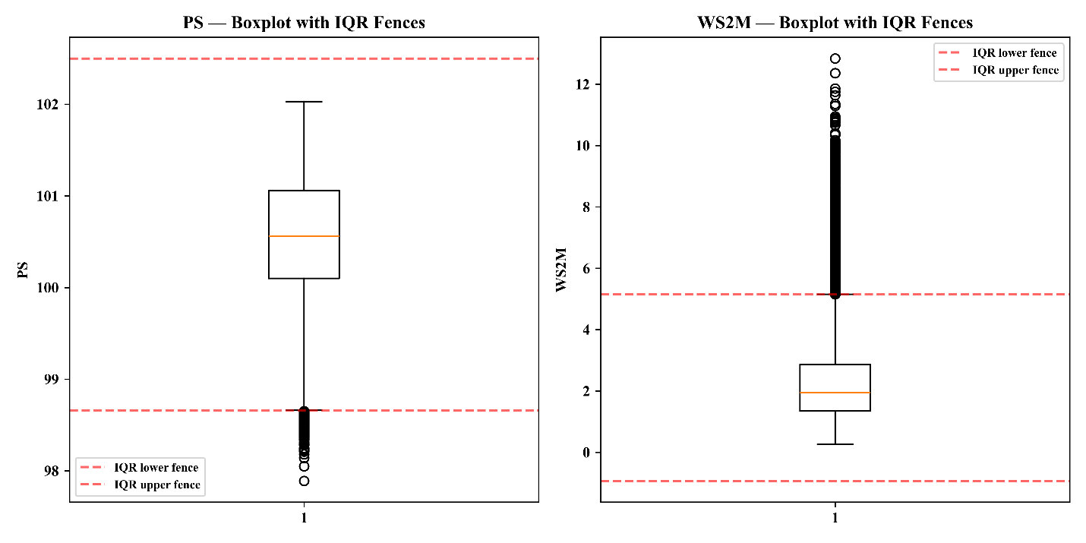
Figure 1: Boxplots of Surface Pressure (PS) and Wind Speed at 2 m (WS2M) with IQR-Based Outlier Fences.
Hence, the approach of don't remove a flag was used. The flagged PS and WS2M observations were kept maintaining the true meteorological variability, and extreme rainfall observations were kept as they are the target phenomenon. The boxplots in Figure 1 support these decisions by visualizing the distribution of flagged observations with respect to the IQR boundaries.

Duplicate Records
The full merged data was used for checking for exact-duplicate rows using pandas.duplicated().sum(). There were no exact duplicates found. No near duplicate detection (e.g., fuzzy matching) was applied because the join key for this dataset (Station + date) is unique by construction, each Station reports at most one observation per calendar date, hence near-duplicates are structurally unlikely, but not unchecked.

Data Encoding, Labeling & Feature Extraction

Encoding
The only categorical variable in the dataset was Station, which was encoded using target encoding: Each station value was replaced with its mean historical BMD_Rainfall computed using only the years in the training period (1984–2007) to ensure that no information from the validation/test period (2008–2010) was fed into a feature used during training. Target encoding was selected over One-Hot Encoding because 34 stations are feeding into one global model, the model can learn a continuous “this station tends to be wet/dry” signal, instead of 34 separate binary flags with no shared information between stations that are climatically similar (e.g., Sylhet and Srimangal).
There is one categorical variable in this data set. The second encoding method was listed as a general course requirement but was not applied: if there were no second categorical feature present, applying one artificially (e.g., encoding a numeric column as categorical) would not be a true characteristic of this data and was not considered to be useful for this project.

Feature Extraction / Engineering
In addition to station encoding, nine other features were calculated from the temporal and meteorological data to represent seasonality, short-term rainfall persistence, and antecedent atmospheric conditions. The engineered features and their rationale are summarized in Table 6.
For all lag and rolling variables, the temporal integrity of the engineered features was preserved by computing each variable at each station. Important, also discontinuities in the station-specific date sequence were checked in observations. If there was a true gap of more than one day, the lag and rolling features were set to null instead of using a shift() operation to incorrectly join observations that were separated by long periods of time.This prevented artificial temporal relationships across station-history gaps, including the documented 1995–1998 gap at Hatiya. Overall, this procedure affected 244 observations (0.06%), primarily at station-history boundaries.
Table 6: Summary of feature extraction
Feature | Formula / Logic | Motivation
Year, Month, DOY | Extracted from date via pandas .dt accessors | Captures seasonality and monsoon-cycle timing
Rain_lag1, Rain_lag2 | BMD_Rainfall shifted 1 and 2 days, grouped by Station | Rainfall is autocorrelated day-to-day; recent rain is a strong predictor of near-term rain
Rain_7day_avg | 7-day rolling mean of BMD_Rainfall, grouped by Station, using only prior days | Captures recent wet/dry trend beyond a single prior day
Temp_lag1, Humidity_lag1, Pressure_lag1 | T2M, RH2M, PS shifted 1 day, grouped by Station | Weather conditions build over consecutive days; lagged predictors reflect this
This gap-aware feature engineering approach is especially important for rainfall prediction, as it helps avoid temporal leakage and misleading lag relationships. As a result, the engineered predictors are more likely to reflect physically meaningful antecedent conditions rather than patterns caused by missing observation periods.

Feature Scaling
For the Linear Regression baseline model, StandardScaler was used to standardize the numerical meteorological and lag features. These included T2M, RH2M, PS, WS2M, CLOUD_AMT, ALLSKY_SFC_SW_DWN, T2MDEW, along with their corresponding lag variables. The BMD_Rainfall target variable was not scaled, allowing the rainfall predictions and evaluation results to remain in their original unit of millimeters (mm).
Scaling was not applied to the Random Forest and XGBoost models because tree-based algorithms use threshold-based feature splits and are generally unaffected by differences in feature magnitude. Therefore, scaling was selectively applied only where it was relevant to the Linear Regression model, avoiding unnecessary preprocessing for the tree-based models.

Dimensionality Reduction (PCA)
PCA was applied to the seven standardized NASA POWER weather variables (T2M, RH2M, PS, WS2M, CLOUD_AMT, ALLSKY_SFC_SW_DWN, and T2MDEW) to assess feature redundancy and the underlying structure of the meteorological variables. Lagged features and the target variable (BMD_Rainfall) were excluded to preserve their original temporal and predictive information. The first three principal components explained 83.3% of the total variance (PC1: 51.3%, PC2: 20.5%, PC3: 11.5%), exceeding the conventional 80% threshold; therefore, three components were considered sufficient to represent most of the variation in the original seven features (Figure 2).
The first two components accounted for 71.8% of the total variance and showed partial separation between rainfall and no-rain observations (Figure 3). Rainfall observations tended to occur more frequently toward the positive PC1 region, while no-rain observations were relatively more concentrated toward the negative side. However, substantial overlap remained between the two groups, indicating that same-day weather conditions alone do not clearly distinguish rainfall occurrence. This supports the inclusion of lagged and rolling features to capture temporal rainfall persistence and antecedent atmospheric conditions.
The first three principal components explain a large proportion of the total variance, suggesting that there is considerable overlap among the weather variables. This is physically reasonable because variables such as temperature, humidity, dew point, and cloud conditions are closely related. However, PCA was used only for exploratory analysis and was not included in the final modelling pipeline. The original predictors were therefore retained, since Random Forest and XGBoost can work with correlated features while also allowing the individual meteorological variables to remain physically interpretable.
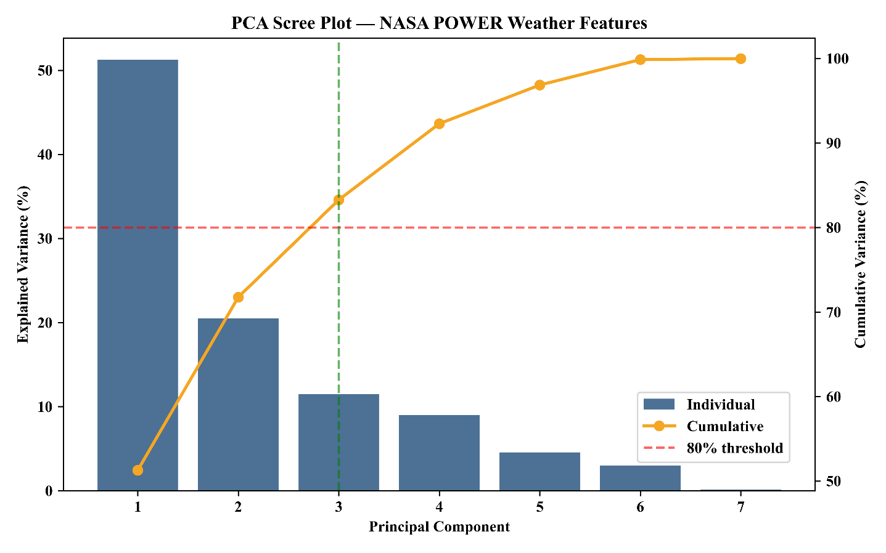

Figure 2: Scree Plot of Principal Component Analysis (PCA) for NASA POWER Weather Features
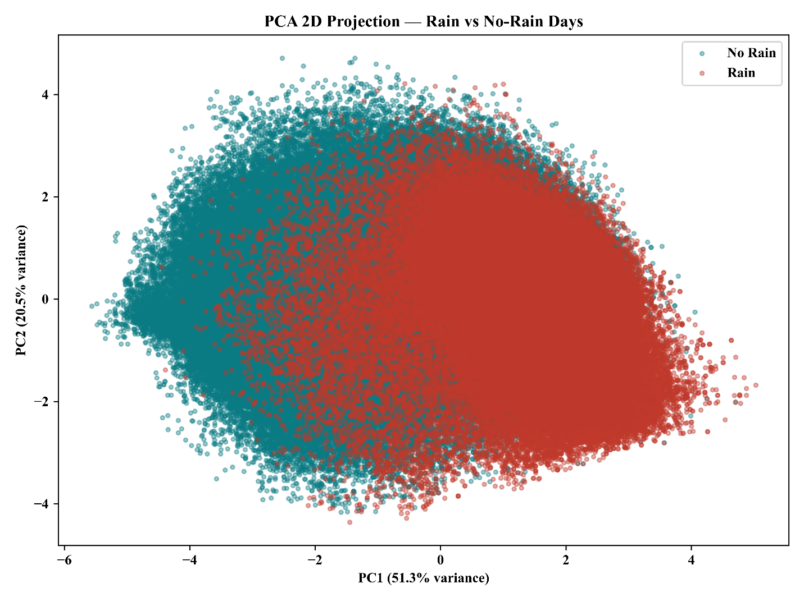
Figure 3: PCA 2D Projection of Standardized NASA POWER Weather Features by Rainfall Occurrence.

Final Cleaned Dataset Summary
The preprocessing steps improved the overall quality and usability of the dataset for analysis. Initially, the dataset consisted of 409,836 observations and 10 variables, with a total of 11,690 missing values. After completing the data cleaning, missing-value treatment, feature engineering, and transformation steps, the number of observations decreased to 397,902, while the number of variables increased to 20. All missing values were addressed during preprocessing, leaving a complete dataset with no remaining missing values.
Table 7: Comparison of the dataset before and after processing
Dataset | Before | After
Rows | 409,836 | 397,902
Columns | 10 | 20
Missing values (total) | 11,690 | 0
During preprocessing, 11,934 observations were removed, mainly because of missing target values and records that were not suitable for analysis. Even after this reduction, the final dataset still contained a sufficiently large number of observations to support the machine learning analysis. The number of variables increased from 10 to 20, which added further analytical value by including engineered temporal, lagged, and meteorological features for the subsequent rainfall prediction modelling (Table 7).

Descriptive Statistics and Visualization
After completing the data cleaning, missing-value treatment, feature engineering, and data transformation steps, the final analysis-ready dataset contained 397,902 daily observations from 34 BMD meteorological stations covering the period from 1984 to 2016. The dataset included 20 variables, consisting of the target variable (BMD_Rainfall), seven NASA POWER meteorological predictors, and several engineered temporal, lagged, and station-encoding features. This final dataset was then used for the subsequent exploratory analysis and development of the machine learning models.

Rainfall (Target Variable)
The BMD_Rainfall variable does not follow a normal distribution and shows a strong concentration of zero-rainfall observations. About 67.84% of the records have no rainfall, indicating a clear zero-inflated pattern in the data. As shown in Table 8, the rainfall distribution also has a high positive skewness value of 5.76. This suggests that most observations have relatively low or zero rainfall, while a smaller number of high-rainfall events contribute considerably to the overall distribution.
Table 8: Descriptive statistics of the rainfall
Statistic | Value
Percentage of dry days (BMD_Rainfall = 0) | 67.84%
BMD_Rainfall skewness (all days) | 5.76 (strong positive skew, zero-inflated)
Mean rainfall, rainy days only | 20.70 mm
Median rainfall, rainy days only | 10.00 mm
Maximum single-day rainfall observed | 590.0 mm
Duplicate rows | 0
For the rainy days, the mean rainfall was 20.70 mm, while the median was 10.00 mm (Table 8). The difference between these two values suggests that a relatively small number of intense rainfall events have a noticeable effect on the mean. The highest recorded daily rainfall was 590.0 mm (Table 8). This extreme value was retained because it represents a meteorologically meaningful rainfall event and cannot necessarily be considered a measurement error.
These characteristics of the rainfall distribution are important when developing the prediction models. The large proportion of dry days, strong positive skewness, and presence of extreme rainfall events suggest that rainfall occurrence and rainfall intensity may need to be considered separately. A two-stage modelling approach could therefore be more suitable, with the first stage predicting whether rainfall occurs and the second estimating the rainfall amount for days when rain is observed, rather than using only a conventional single-stage regression model.

Correlation Analysis
Correlation analysis was performed to examine the strength and direction of the relationships between the numerical variables and to identify weather variables that may be useful for predicting rainfall. The analysis also provided an opportunity to identify multicollinearity and redundancy among the meteorological features, which helped inform the subsequent feature selection and model development.

Rainfall's Strongest Relationships
Pearson correlation analysis indicates that BMD_Rainfall is more strongly associated with its recent rainfall history than with any individual same-day meteorological variable (Table 9). The strongest relationship was observed with Rain_lag1 (r = 0.393), followed by Rain_7day_avg (r = 0.323) and Rain_lag2 (r = 0.247). The stronger correlation with the previous day's rainfall indicates meaningful short-term rainfall persistence, while the lower correlation with Rain_lag2 suggests that this temporal dependence weakens with increasing lag.
The correlation of Rain_7day_avg falls between those of Rain_lag1 and Rain_lag2 (Table 9), suggesting that it reflects the recent wet or dry conditions over a broader period rather than the effect of rainfall on only one preceding day. Overall, these findings support the use of short-term lagged and rolling rainfall features in the predictive modelling framework.

Relationships Among Weather Features
The correlation matrix shows clear relationships among several of the meteorological predictors (Figure 4). T2M and T2MDEW have a strong positive relationship, while RH2M and CLOUD_AMT also show a positive association. These relationships are expected because the variables describe related aspects of atmospheric temperature and moisture conditions. The observed redundancy among the predictors is also consistent with the PCA results, where three principal components accounted for 83.3% of the total variance in the seven original weather variables.
Table 9: Correlation analysis coefficient (r) value
Variable pair | Pearson r
BMD_Rainfall vs Rain_lag1 (yesterday's rainfall) | 0.393
BMD_Rainfall vs Rain_7day_avg | 0.323
BMD_Rainfall vs Rain_lag2 (two days prior) | 0.247
In comparison, WS2M and PS have relatively weak relationships with most of the other predictors, indicating that they contribute information that is more distinct from the remaining weather variables. PS, in particular, shows negative associations with T2M, RH2M, CLOUD_AMT, and T2MDEW (Figure 4). This suggests that pressure tends to vary in the opposite direction to the group of features related to temperature, moisture, and cloud conditions.This supports retaining PS as an independent predictor rather than treating it as redundant with the strongly correlated atmospheric variables.
Overall, the correlation analysis highlights two main features of the predictor set. First, rainfall prediction can benefit from information on rainfall observed in previous periods. Second, several same-day meteorological variables are strongly correlated with one another. These findings provide statistical support for including lagged and rolling rainfall features and for carrying out further feature-selection analysis. The PCA results also support the presence of redundancy among the original predictors (Table 9; Figure 4).
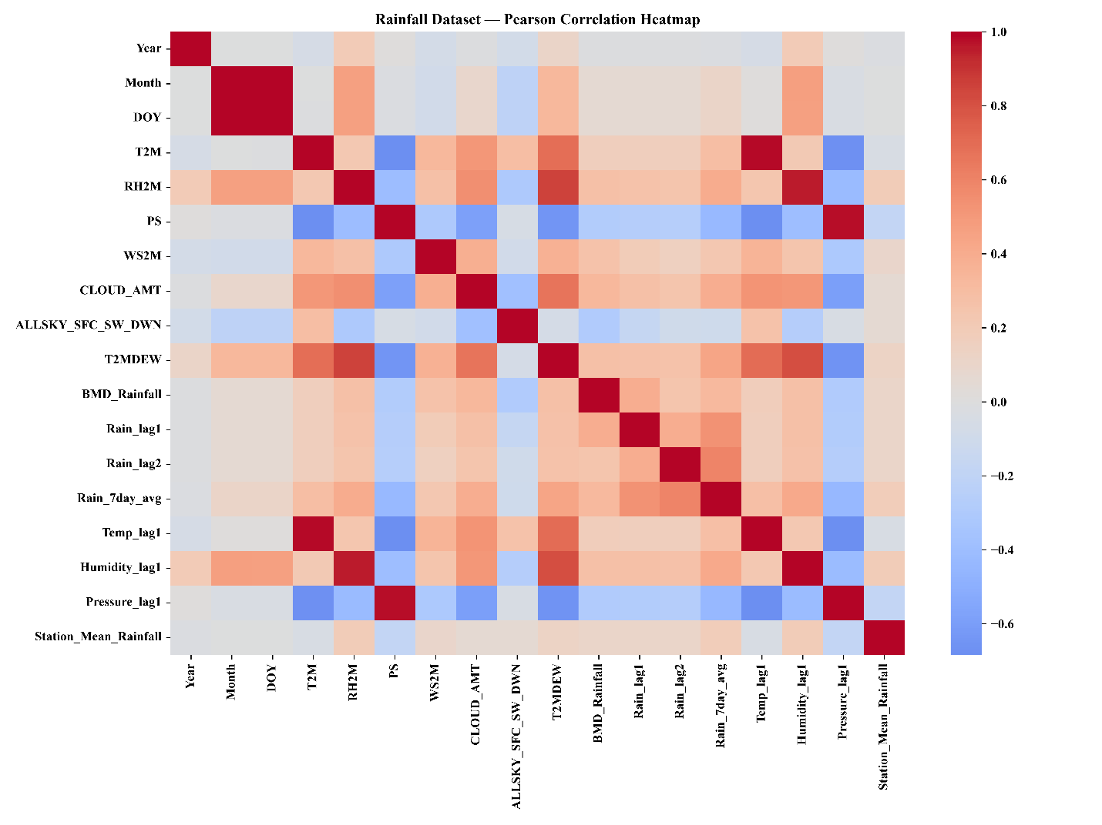
Figure 4: Pearson Correlation Heatmap of Meteorological, Temporal, and Rainfall-Related Features
  - Exploratory Data Analysis

Exploratory Analysis of Daily Rainfall
Figure 5 shows that the daily rainfall distribution is strongly right-skewed and has a clear zero-inflated pattern. Of the 397,902 observations, approximately 67.8% correspond to dry days with 0 mm of rainfall. Most of the recorded rainfall amounts are relatively low, and the number of observations decreases quickly as rainfall intensity increases. The distribution has a long right-hand tail that extends to about 590 mm, reflecting the presence of relatively infrequent but extreme rainfall events. This uneven rainfall distribution suggests that both the occurrence of rainfall and the amount of rainfall should be considered when developing the subsequent prediction models.
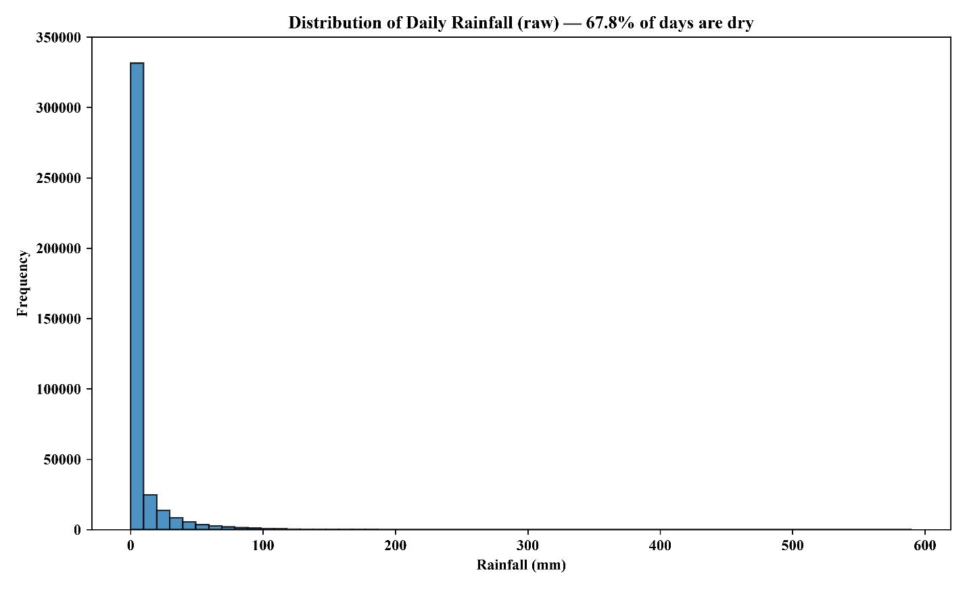
Figure 5: Distribution of Daily Rainfall in the Analysis-Ready Dataset.

Distribution of Rainfall Amount on Rainy Days Only
As shown in Figure 6, the rainfall distribution for rainy days remains strongly positively skewed even after applying the log(1 + rainfall) transformation. The highest frequencies are found at the lower end of the transformed scale, showing that most rainfall events are relatively low in intensity. The frequency generally decreases as rainfall amount increases, resulting in a long right tail that extends to approximately log(1 + rainfall) ≈ 6.2.
The distribution also contains several local fluctuations in frequency instead of following a completely smooth downward pattern. These variations suggest that rainfall intensity is not evenly distributed and may be related to differences in seasonal rainfall processes and event intensity. However, the overall distribution clearly shows that low- to moderate-intensity rainfall events occur much more frequently than high-intensity events.
The long upper tail is important for the modelling stage because a relatively small number of intense rainfall events may have a strong influence on conventional regression models. Applying the log(1 + rainfall) transformation compresses this upper tail and reduces the difference in scale between ordinary and extreme rainfall observations while preserving the relative ordering of rainfall amounts. Therefore, the transformed distribution is more suitable for exploratory analysis and may also improve the stability of rainfall-amount modelling.
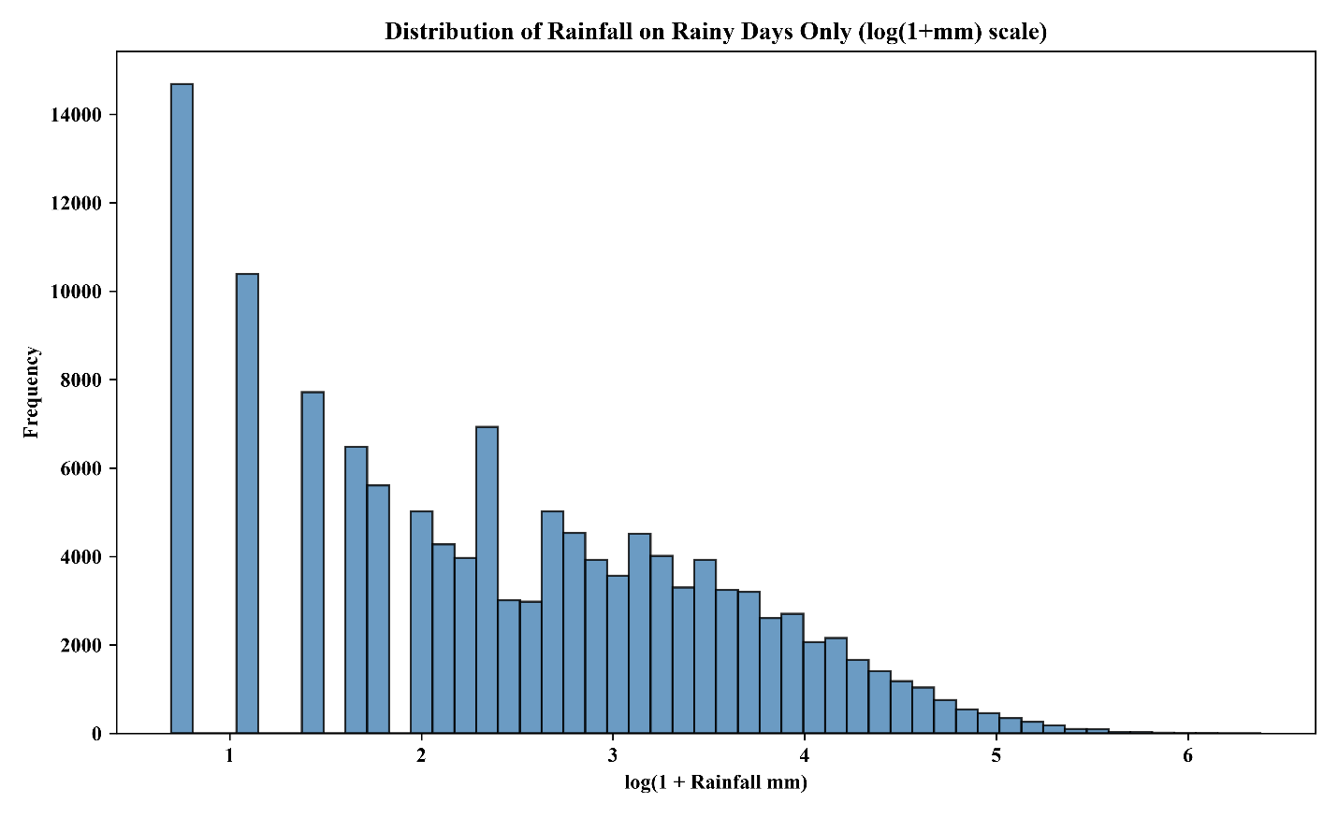
Figure 6: Distribution of Daily Rainfall Amounts on Rainy Days Using a Log(1 + Rainfall) Transformation
Importantly, the transformation does not eliminate the underlying extreme rainfall signal; rather, it reduces its numerical dominance. Therefore, the observed distribution supports treating rainfall occurrence and rainfall intensity as distinct modelling challenges, with the rainy-day subset providing the basis for evaluating rainfall-amount prediction.

Regional Variation in Rainfall
As shown in Figure 7, rainfall exhibits clear differences among the four geographic regions of Bangladesh. Hill/Northeast shows the highest rainfall distribution and the greatest variability, with the upper whisker reaching approximately 15 mm in the displayed range. Coastal stations show the second-highest variability, with values extending to around 10 mm. In contrast, Central and Plains/North regions generally exhibit lower rainfall distributions, with upper whiskers of approximately 5 mm and 2 mm, respectively.
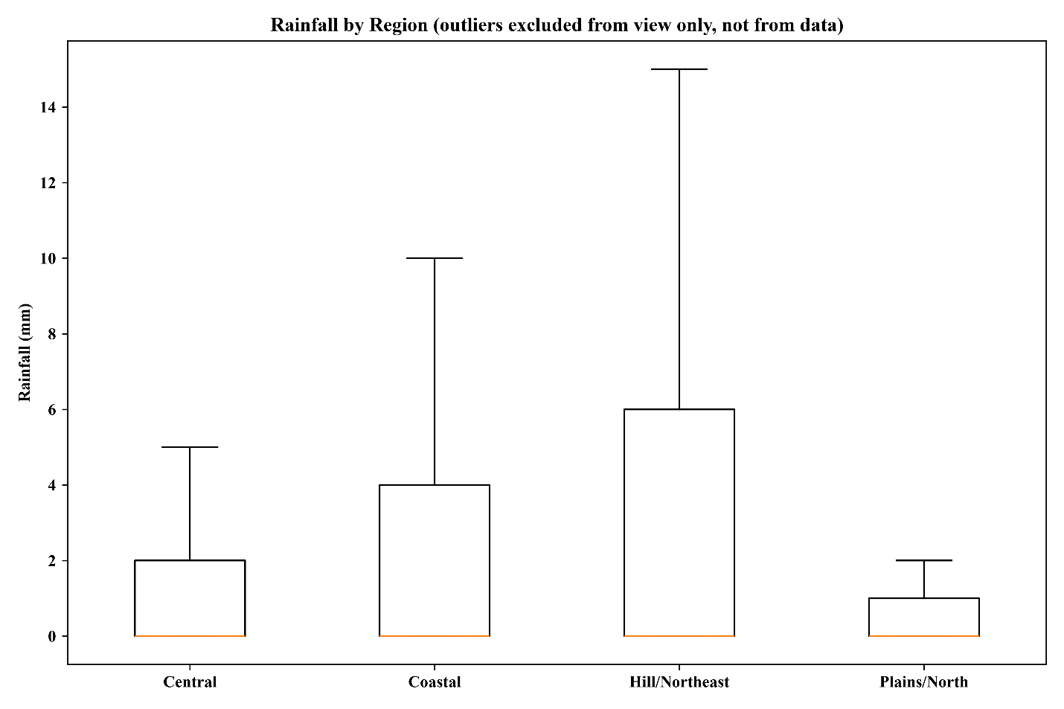
Figure 7: Regional Distribution of Daily Rainfall Across Four Geographic Regions
The widespread observed in the Hill/Northeast and Coastal regions indicates greater variability in rainfall intensity compared with the Central and Plains/North regions. The large proportion of observations at or near zero across the regions also reflects the strong dry-day component identified in the overall rainfall distribution (Figure 5). These regional differences suggest that geographical location is an important factor influencing rainfall patterns and therefore support the inclusion of station or regional information in the rainfall prediction framework. For visualization clarity, extreme outliers were excluded only from the plotted view and were retained in the underlying dataset and statistical analyses (Figure 7).

Distribution and Relationships Among Meteorological Features
The seven NASA POWER weather variables show different distributional patterns, reflecting the distinct characteristics of the underlying meteorological conditions (Figure 8). T2M is slightly to moderately left-skewed, with most observations concentrated between approximately 27 and 30°C. The distribution also has a relatively longer tail toward lower temperatures.
RH2M is also negatively skewed, with most observations concentrated at relatively high humidity levels and a longer tail toward lower humidity values. PS has a comparatively narrow and approximately symmetric distribution around 100–101 kPa, although several peaks are visible, potentially reflecting seasonal and spatial variation in atmospheric pressure. In contrast, WS2M is strongly right-skewed, with most observations occurring at relatively low wind speeds and a long upper tail representing less frequent high-wind conditions.
CLOUD_AMT exhibits a distinctive U-shaped or bimodal distribution, with relatively high frequencies at both low and high cloud-cover levels, rather than following a conventional normal or skewed distribution. ALLSKY_SFC_SW_DWN shows a comparatively smooth, approximately unimodal distribution centered around moderate solar-radiation values. T2MDEW is strongly left-skewed, with observations concentrated toward higher dew-point temperatures and a longer tail toward lower values, consistent with the predominantly humid conditions represented in the dataset.
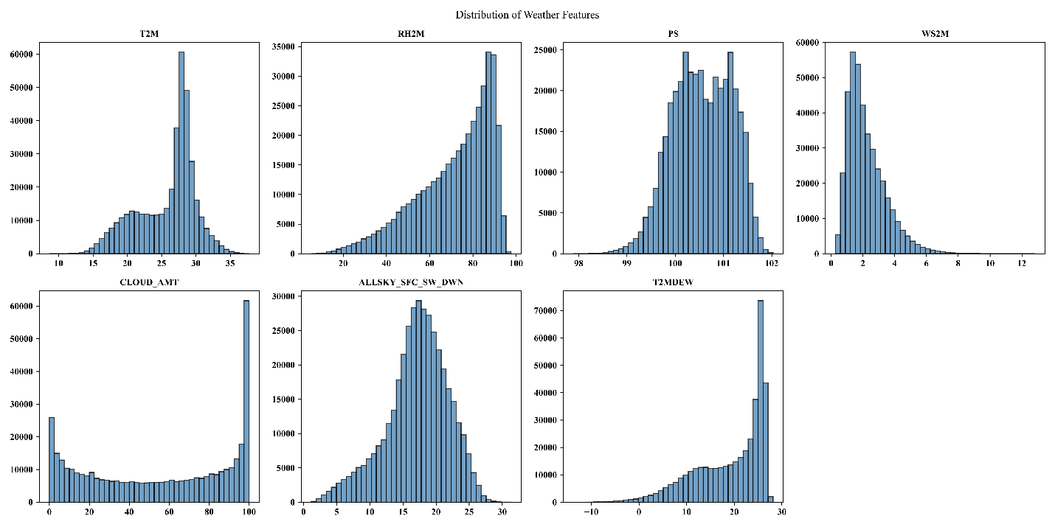
Figure 8: Distribution of NASA POWER Weather Features.
The distributions shown in Figure 8 are also consistent with the relationships identified through the correlation analysis (Figure 4; Table 9). T2M and T2MDEW show a strong positive relationship because both are closely associated with atmospheric temperature and moisture conditions, while RH2M and CLOUD_AMT exhibit a positive relationship associated with atmospheric moisture and cloud formation. Conversely, PS shows negative relationships with several temperature- and moisture-related variables, including T2M, RH2M, CLOUD_AMT, and T2MDEW. WS2M shows comparatively weaker relationships with most other predictors, suggesting that it may provide relatively distinct information. Overall, Figure 8 demonstrates considerable variation in distributional shape and skewness across the predictors, while the correlation results confirm that some variables contain overlapping information. These characteristics provide an important basis for subsequent feature assessment, PCA, and model-specific preprocessing.
T2M's two visible peaks correspond to the cooler dry season and the hotter monsoon season, rather than a single typical temperature. CLOUD_AMT's U-shape shows days cluster at the extremes (mostly clear or mostly overcast) far more than in a partly cloudy middle state. RH2M and T2MDEW both lean toward their higher end, reflecting Bangladesh's generally humid conditions outside the drier winter months. WS2M's long right tail highlights that while most days are calm, a meaningful minority experience notably higher wind, plausibly storm associated. None of the seven variables follows a standard normal distribution. Instead, each has a distinct distributional pattern that can be explained by its underlying meteorological characteristics rather than simply being a result of the data collection process. This has an important implication for model development. Methods that work best when input features are approximately normal and unimodal, such as untransformed linear regression, may be less effective for these types of distributions. In contrast, tree-based models such as Random Forest and XGBoost do not require normally distributed predictors and can flexibly handle features with bimodal or U-shaped patterns, such as T2M and CLOUD_AMT.

Relationship Between Relative Humidity and Rainfall
As shown in Figure 9, both rainfall occurrence and rainfall intensity generally increase as relative humidity (RH2M) rises. Most observations with no rainfall are located along the zero-rainfall line and occur across a wide range of humidity values, particularly at low to moderate humidity levels. In comparison, rainfall observations become more concentrated at higher relative humidity, especially above approximately 70–80%. This pattern suggests that higher atmospheric moisture is associated with a greater likelihood of rainfall.
The relationship, however, is not purely linear. At high humidity levels, rainfall amounts vary substantially, ranging from near-zero rainfall to extreme events exceeding 250 mm. This indicates that high humidity may be an important condition for rainfall occurrence, but it does not independently determine rainfall intensity. The increasing spread of rainfall values at higher humidity levels also suggests a threshold-like or nonlinear relationship, which may not be adequately represented by a simple Pearson correlation coefficient.The figure also shows that extreme rainfall events are predominantly observed at high humidity, with the largest rainfall amounts occurring around approximately 80–95% relative humidity (Figure 9). This pattern provides useful evidence that RH2M contains predictive information for rainfall modelling, while also highlighting the need for machine learning models capable of capturing nonlinear interactions among humidity and other meteorological variables.
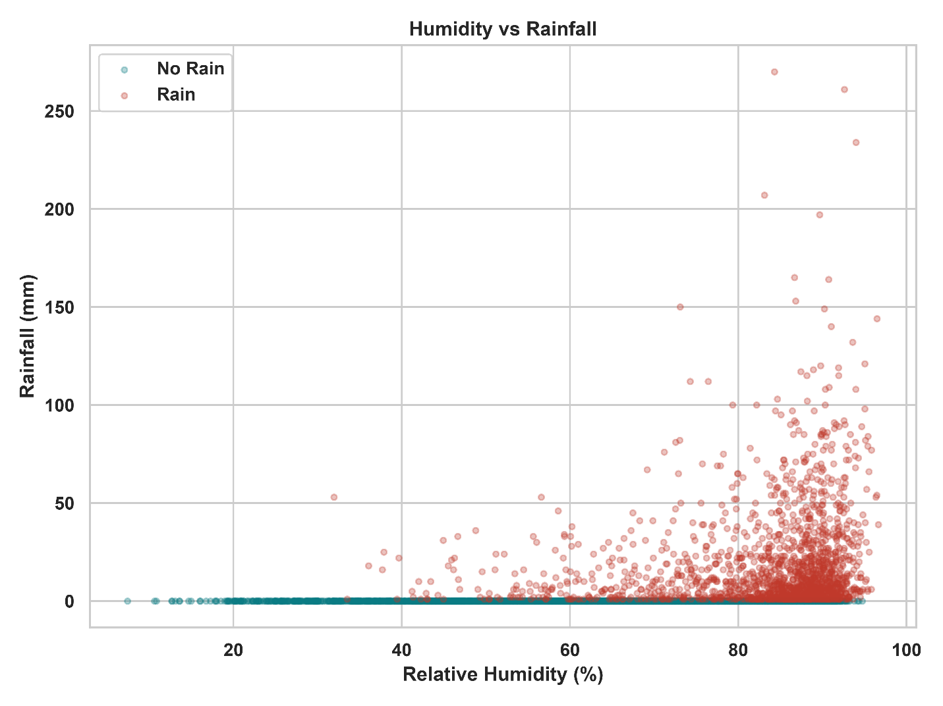
Figure 9: Relationship Between Relative Humidity and Daily Rainfall Occurrence and Amount.

Regional Variation in Rainfall Occurrence
As shown in Figure 10, the percentage of days with measurable rainfall varies across the four regions. Hill/Northeast records the highest rainy-day rate at approximately 39%, followed by the Coastal region (~33%) and Central region (~31%). The Plains/North region has the lowest rainy-day rate at approximately 29%.
This pattern indicates clear regional differences in rainfall occurrence, with Hill/Northeast experiencing measurable rainfall on roughly 10 percentage points more days than Plains/North. The relatively gradual decline from Hill/Northeast to Plains/North suggests that geographic location is an important factor in determining the likelihood of rainfall. These differences may reflect variations in local climate and atmospheric conditions across Bangladesh. The regional variation observed in Figure 10 also supports the inclusion of station or regional information as a predictor in the machine learning models. However, this figure describes rainfall occurrence only, not rainfall intensity; therefore, a higher rainy-day rate does not necessarily mean that a region receives greater rainfall amounts on individual rainy days.
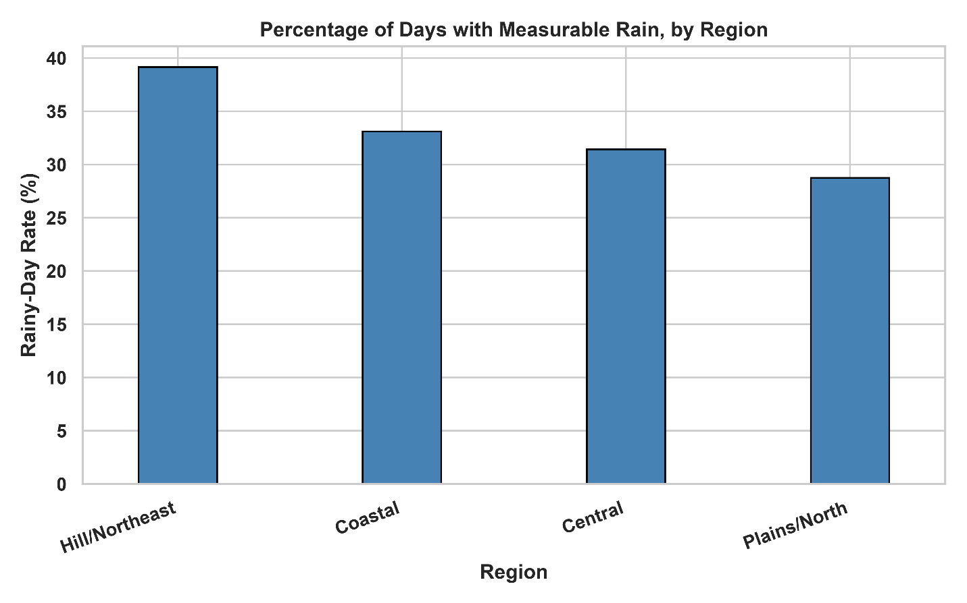
Figure 10: Regional Variation in Rainy-Day Frequency (%).

Monthly Seasonality of Rainfall and Temperature
Rainfall exhibits a strong seasonal pattern across the year, with substantially higher rainfall during the monsoon months (June–September) and very low rainfall during the dry-season months, particularly December–February, as illustrated in Figure 11. Mean monthly rainfall begins to increase from March, rises considerably during the following months, and reaches a high level in June, with the peak occurring in July at approximately 17 mm. It then declines through August and September before dropping more sharply from October. Rainfall remains very low in November and December. Temperature follows a different seasonal pattern. As shown by the line in Figure 11, the mean temperature increases from January and reaches its highest level around April–May, at approximately 30°C. After this period, temperature gradually decreases through the monsoon season and reaches its lowest level around December–January. This pattern indicates that the relationship between temperature and rainfall is not simply linear throughout the year.
Figure 11 therefore highlights a clear seasonal and nonlinear relationship between rainfall and temperature. Although rainfall increases substantially during the monsoon, temperature has already started to decline from its annual maximum. This suggests that rainfall variability is influenced by broader seasonal atmospheric processes rather than temperature alone. The strong monthly seasonality also supports the inclusion of Month, Day of Year (DOY), and other temporal features in the machine learning models to capture recurring seasonal patterns in rainfall.
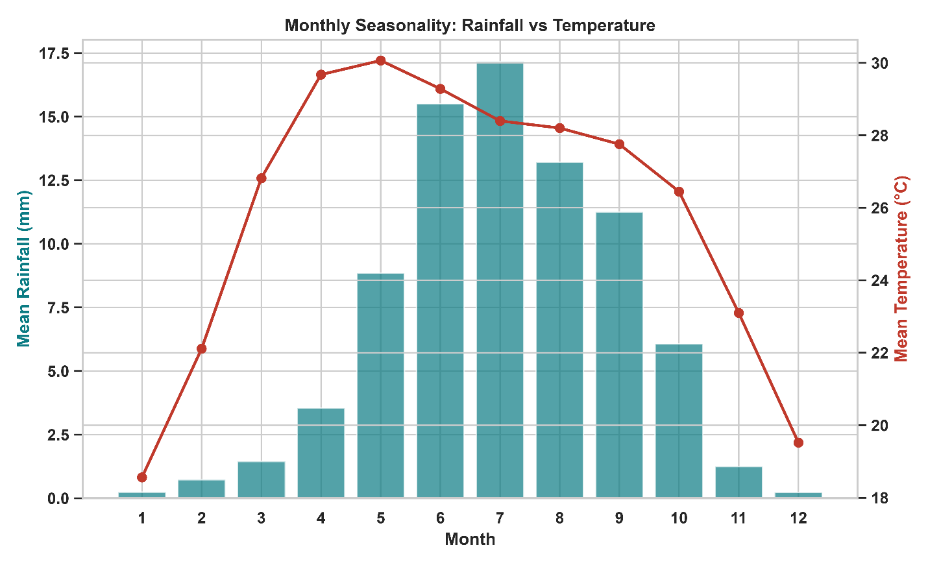
Figure 11: Seasonal Variation in Mean Monthly Rainfall and Temperature.

Seasonal and Regional Variation in Rainfall Occurrence
Rainfall occurrence shows a strong and consistent seasonal pattern across all four regions, as illustrated in Figure 12. Rainfall occurrence is very low during January–February, gradually increases from March, and rises sharply from April onward. The rainy-day rate reaches its highest-level during June–August, followed by a gradual decline from September and a sharp reduction during October–December.
Among the regions, Hill/Northeast generally records the highest rainy-day rates during the wet season, reaching 81% in July and 78% in August. The Coastal region shows a similar but slightly lower pattern, with rainy-day rates of 78% in July, 74% in August, and 61% in September. The Central region reaches 71% in July and 66% in August, while Plains/North records comparatively lower rates of 67% and 59%, respectively (Figure 12). The regional differences become particularly pronounced during the transition into the monsoon. For example, in April, the rainy-day rate ranges from 20% in Plains/North to 38% in Hill/Northeast, while in May it increases to 57% in Hill/Northeast compared with 39–43% in the other regions. During the dry season, however, the regional differences are much smaller, with most regions recording only 2–4% rainy days in December.
Overall, Figure 12 demonstrates that rainfall occurrence in Bangladesh is governed by a strong combination of seasonality and geographic variation. The consistent monsoon peak across all regions, together with differences in its magnitude and onset, highlights the importance of incorporating temporal features such as Month/DOY and spatial information such as Station or Region into the rainfall prediction models.
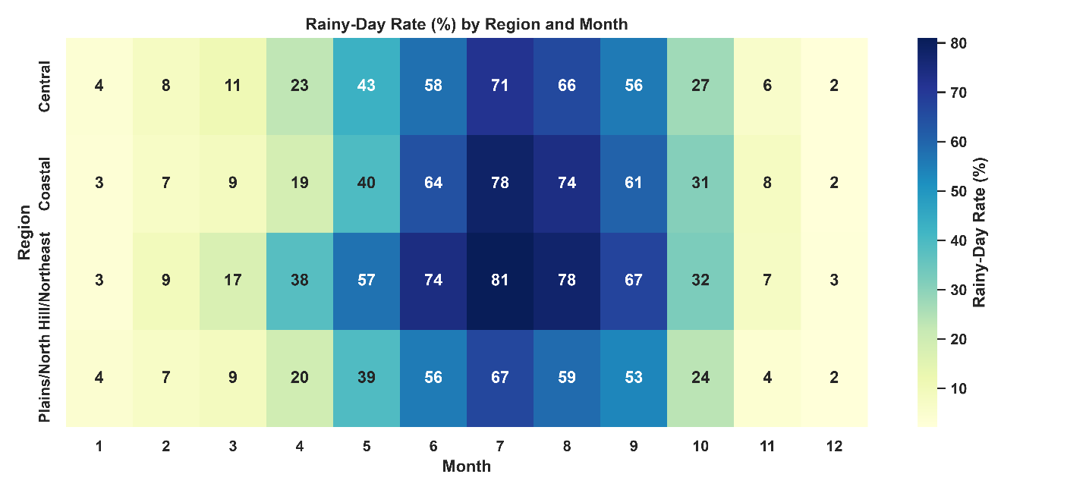
Figure 12: Seasonal and Regional Variation in Rainy-Day Frequency.

Patterns, Trends & Anomalies
The analysis of patterns, trends, and anomalies is important because it helps determine whether the dataset contains meaningful temporal, seasonal, regional, and meteorological structures before developing the prediction models. It helps identify recurring rainfall patterns, long-term and interannual variations, unusual observations, and potential data-quality issues. Understanding these characteristics ensures that genuine meteorological extremes are not incorrectly removed as errors and help guide appropriate feature engineering, preprocessing, model selection, and interpretation of prediction results.

National Monthly Rainfall Trend
As shown in Figure 13, national monthly rainfall totals exhibit a strong and highly consistent seasonal cycle throughout 1984–2016. Rainfall totals rise sharply during the monsoon period and decline to very low levels during the dry season, producing a repeated annual pattern. The 3-month rolling average follows the same seasonal cycle while smoothing short-term fluctuations, confirming that the observed peaks and troughs are not isolated monthly events but part of a persistent seasonal rainfall regime.
The seasonal pattern remains fairly consistent throughout the study period, but the amount of rainfall recorded in each month varies noticeably from one year to another. Some years experienced very high monsoon rainfall, while other years had much lower peaks. This year-to-year variation shows that rainfall changes considerably around the main seasonal pattern. Therefore, although the monthly rainfall series clearly shows strong seasonality, it is difficult to identify a consistent long-term increase or decrease in national rainfall based on visual inspection alone (Figure 13).
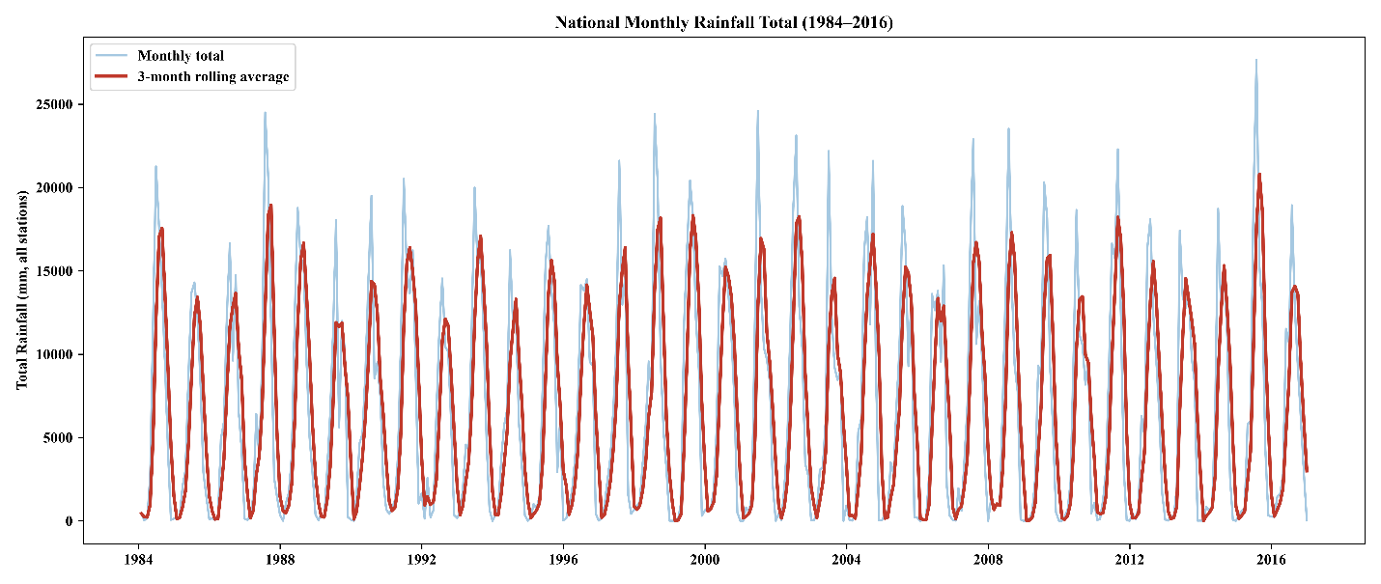
Figure 13: National Monthly Rainfall Trend with 3-Month Rolling Average, 1984–2016.

National Annual Rainfall Trend
The annual rainfall totals presented in Figure 14 show considerable variation from year to year during the period 1984–2016. Across all stations, the annual totals range approximately from 63,000 to 94,000 mm. Higher rainfall totals can be seen in years such as 1991, 1993, 1998, 2003, and 2015, while comparatively lower totals were recorded around 1992, 1994, 2006, 2010, and 2014 (Figure 14).
Unlike the monthly rainfall pattern, the annual totals remove the strong seasonal cycle and make the differences between individual years more visible. There is no clear and consistent upward or downward trend over the study period. Instead, the rainfall totals vary between relatively wetter and drier years, indicating that year-to-year variability is an important feature of the national rainfall pattern. However, these results are based on descriptive observation only. A formal statistical trend test would be necessary to determine whether the observed long-term variation is statistically significant.
Overall, Figures 13 and 14 indicate that rainfall in Bangladesh is characterized by a strong and persistent seasonal cycle combined with substantial interannual variability, rather than a simple linear long-term trend. This temporal variability further supports the inclusion of seasonal and temporal features in the machine learning framework to improve rainfall prediction.
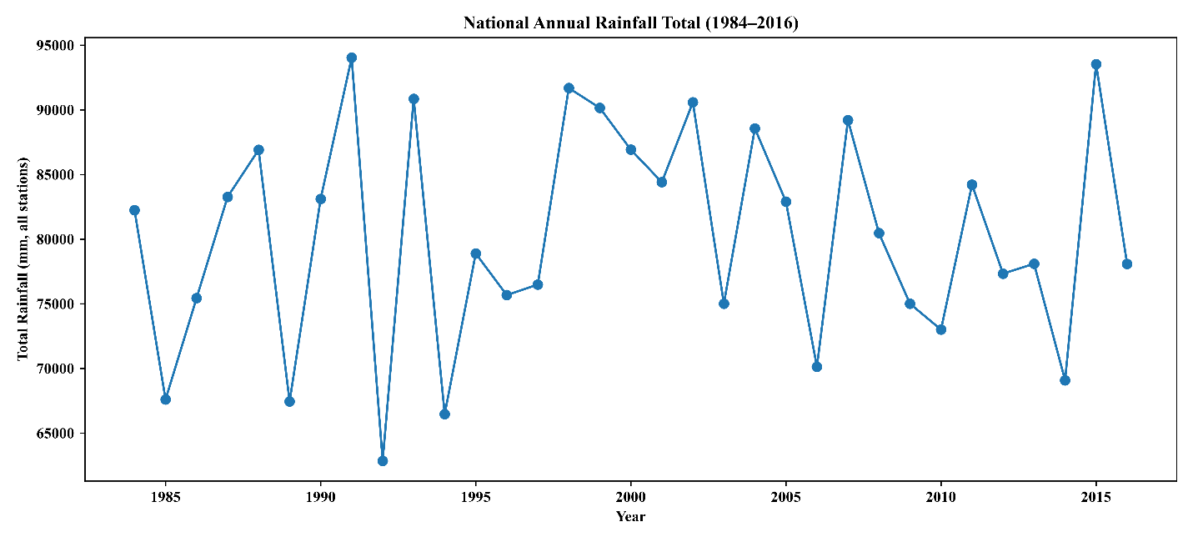
Figure 14: National Annual Rainfall Trend, 1984–2016.

Multivariate Anomaly Detection
As shown in Figure 15, most observations form a dense cluster in the upper-right region, approximately 80–95% relative humidity and 27–30°C, representing the highly consistent atmospheric conditions commonly observed during the monsoon season. In contrast, the Isolation Forest anomalies (red X) are concentrated predominantly in the lower-humidity region (below approximately 35%) and span a much wider temperature range of roughly 13–36°C. This pattern suggests that the flagged observations primarily represent dry-season meteorological variability, which is naturally more diverse than the highly repetitive monsoon conditions, rather than data-quality errors.
Of the 7,958 observations flagged by Isolation Forest, 5,015 (63%) also overlapped with observations identified by the univariate IQR/Z-score approach. This overlapping group therefore represented the highest priority set for quality assessment. Manual spot-checking of sampled observations confirmed that these records were physically plausible dry-season measurements rather than data-entry errors. Consequently, no additional observations were removed based solely on the multivariate anomaly analysis.
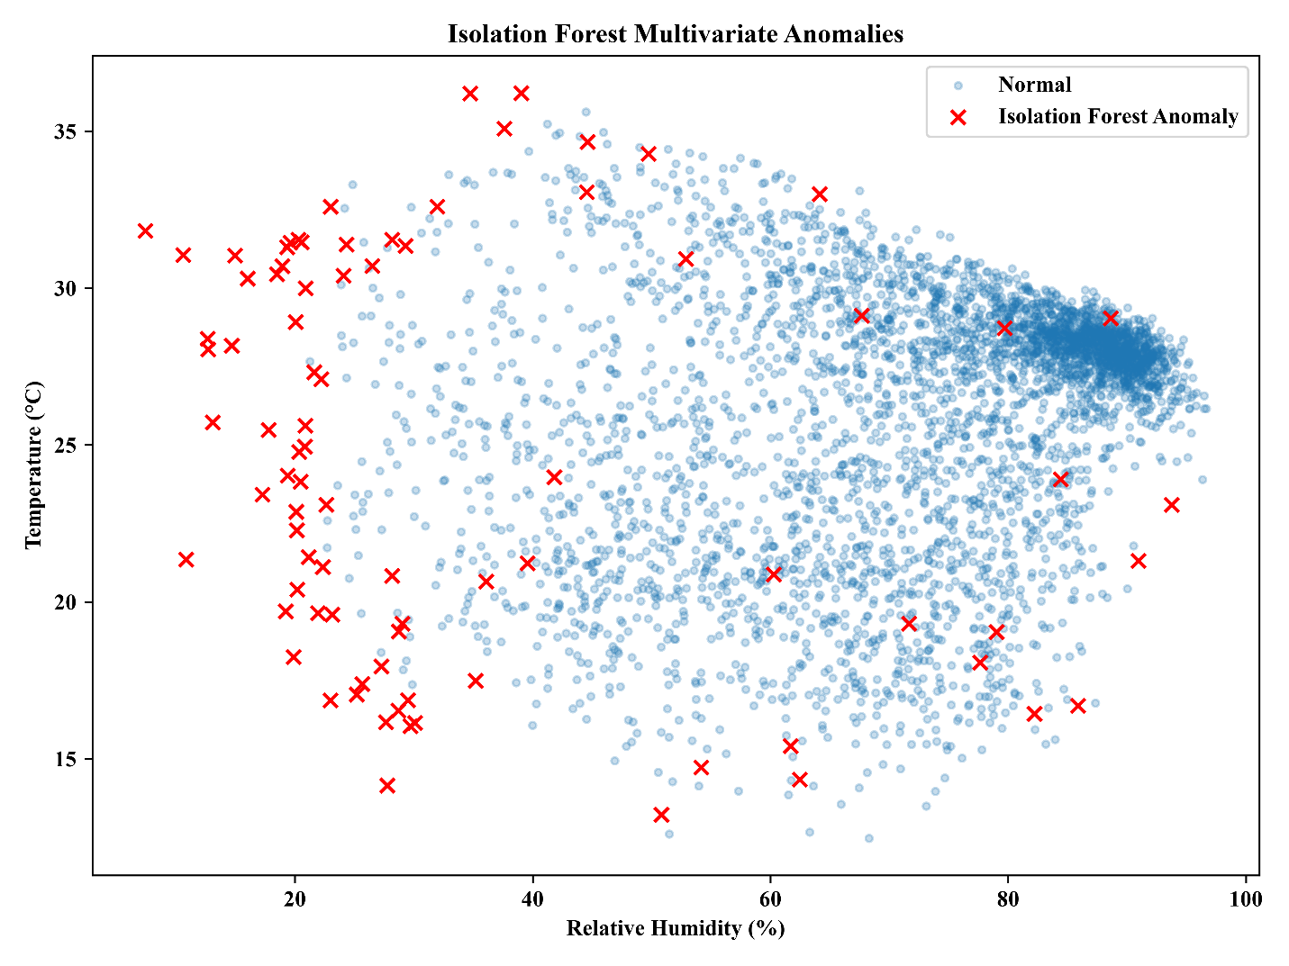
Figure 15: Multivariate Weather Anomaly Detection Using Isolation Forest
Overall, Figure 15 suggests that most of the detected anomalies are related to seasonal and structural patterns in the data rather than being errors. For this reason, these observations were retained so that the machine learning models could capture the natural variation associated with different seasons. The results also support including Month/DOY and Station as predictive features, allowing the models to account for differences between dry-season and monsoon-season conditions instead of treating these variations as unexplained noise.

Preliminary Modeling
The interim report guideline permits either classification or regression metrics for this milestone. Two model tracks were planned: a Logistic Regression classifier predicting next-day rain occurrence, and a Linear Regression baseline predicting next-day rainfall amount. Only the classification track has been built and evaluated as of this report; the regression track and the mandatory naive seasonal baseline are scheduled for the coming week (see Section 6).

Logistic Regression Model Results and Interpretation
Logistic Regression was used as a baseline classification model to predict whether rainfall would occur on the following day. The target variable was shifted forward by one day separately for each station, allowing the model to use information available before the rainfall event to make the prediction. This setup provides a more realistic forecasting framework compared with the earlier same-day prediction approach.

Class Distribution and Model Performance
Figure 16 shows the distribution of the target classes. The dataset contains considerably more no-rain days than rain days, indicating a clear imbalance between the two classes. To account for this imbalance, the model was configured with class_weight='balanced', which gives greater weight to the minority rain class during model training.
The Logistic Regression model achieved an overall accuracy of 82.6%. For the Rain class, the model obtained a precision of 67.3%, a recall of 85.9%, and an F1-score of 75.4%. The relatively high recall shows that the model was able to identify most of the actual rainfall events. This can be useful in situations where failing to detect a rainfall event may be more problematic than issuing an occasional false rainfall prediction.
The confusion matrix shown in Figure 18 gives a clearer picture of the model's predictions. The model correctly identified 20,764 no-rain days and 9,973 rain days. At the same time, 4,855 no-rain days were incorrectly predicted as rain, while 1,638 actual rain days were classified as no rain. Therefore, the number of false positives is considerably higher than the number of false negatives. This helps explain why the model achieved relatively high recall for rainfall but comparatively lower precision.
Overall, the results suggest that the Logistic Regression model was better at detecting rainfall events than at avoiding false rainfall predictions. This pattern is consistent with the use of balanced class weights, which gives additional importance to the minority Rain class during model training.

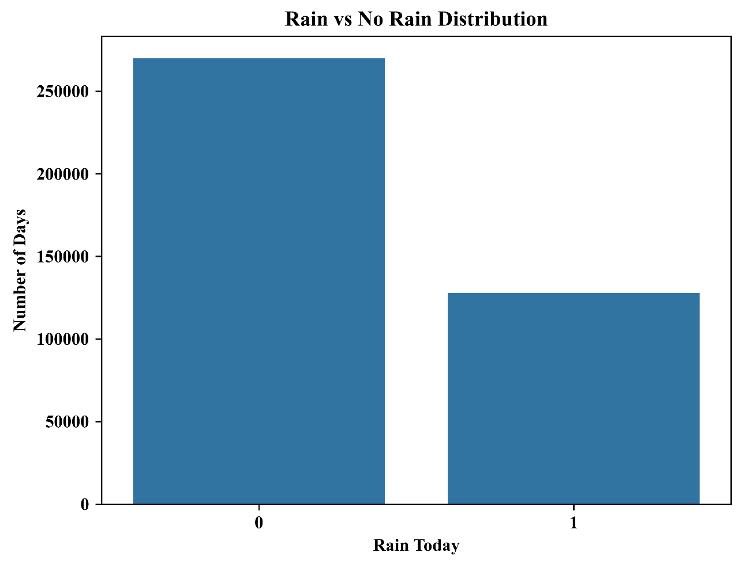
Figure 16: Distribution of Rainy and Non-Rainy Days in the Dataset

Interpretation of Feature Coefficients
The Logistic Regression coefficients are shown in Figure 17. The sign and magnitude of each coefficient indicate how the corresponding standardized predictor is related to the probability of rainfall on the following day. Positive coefficients increase the predicted log-odds of rainfall, while negative coefficients reduce them.
Among the predictors, RH2M has the largest positive coefficient, indicating that relative humidity is the strongest positive predictor in the model. In other words, higher atmospheric humidity is associated with a higher predicted probability of rainfall. T2M and CLOUD_AMT also have relatively large positive coefficients, suggesting that temperature and cloud conditions contribute useful information for distinguishing between rainy and non-rainy days.
In contrast, Humidity_lag1 has the largest negative coefficient, followed by ALLSKY_SFC_SW_DWN and PS (Figure 17). The negative coefficient for solar radiation is physically reasonable because higher incoming solar radiation is generally associated with clearer atmospheric conditions, which are less favorable for rainfall. However, the negative relationship between previous-day humidity and rainfall should be interpreted with some caution. The meteorological predictors are related to one another, so this coefficient represents the relationship with rainfall after the effects of the other variables in the model have been taken into account.
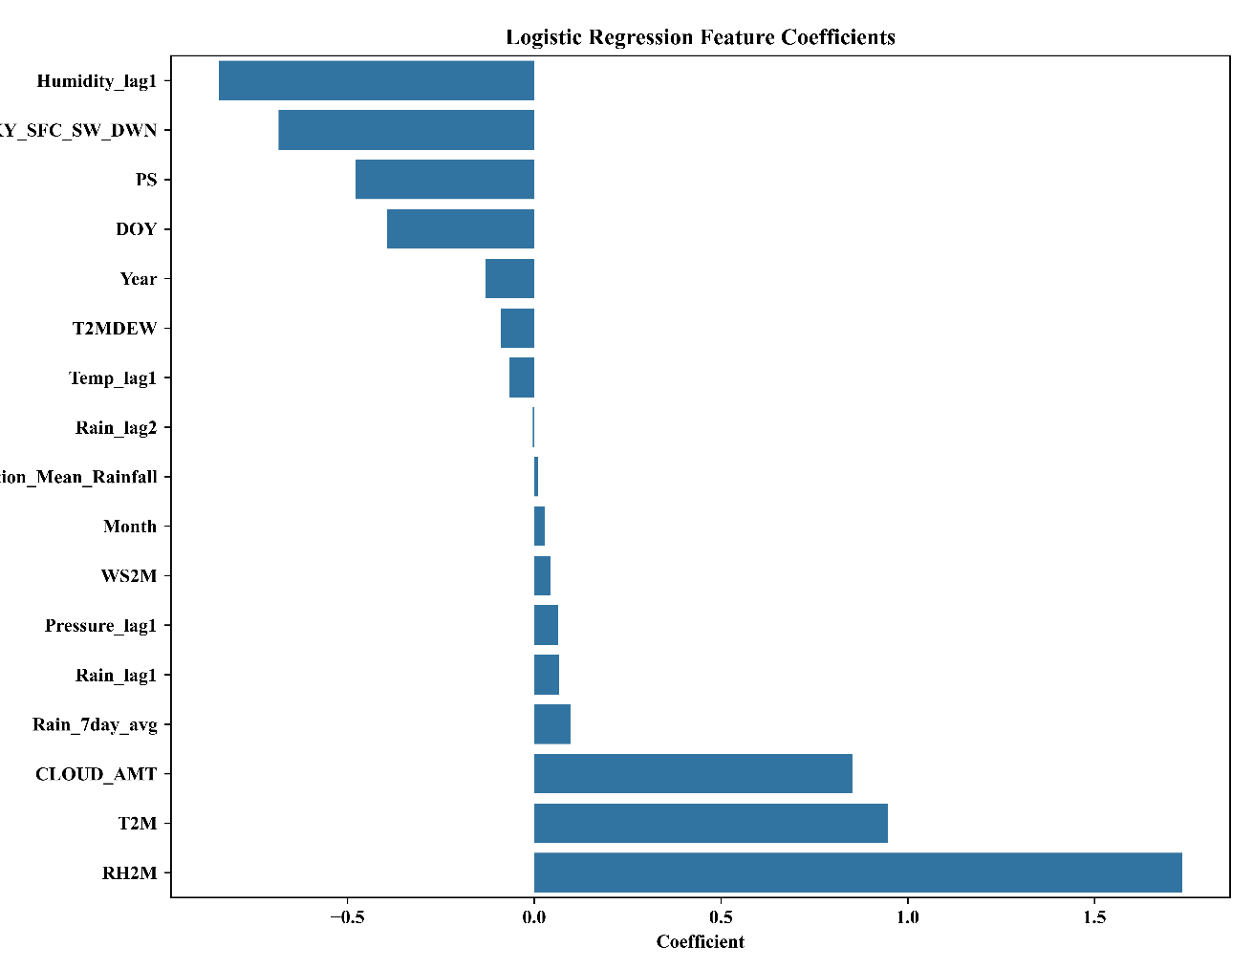
Figure 17: Logistic Regression Coefficients for Rainfall Occurrence Prediction
The coefficients of Rain_lag1, Rain_lag2, Rain_7day_avg, Month, WS2M, Pressure_lag1, and Temp_lag1 are comparatively smaller in this fitted Logistic Regression model. This does not necessarily indicate that these variables have no predictive value; rather, their linear contribution after controlling other correlated predictors is relatively limited.

Confusion Matrix Analysis
The confusion matrix shown in Figure 18 demonstrates that the model correctly identified 9,973 of the actual rainy days, while missing 1,638 rainfall events. This corresponds to the reported 85.9% recall. For no-rain observations, 20,764 days were correctly classified, while 4,855 were incorrectly labelled as rainy.
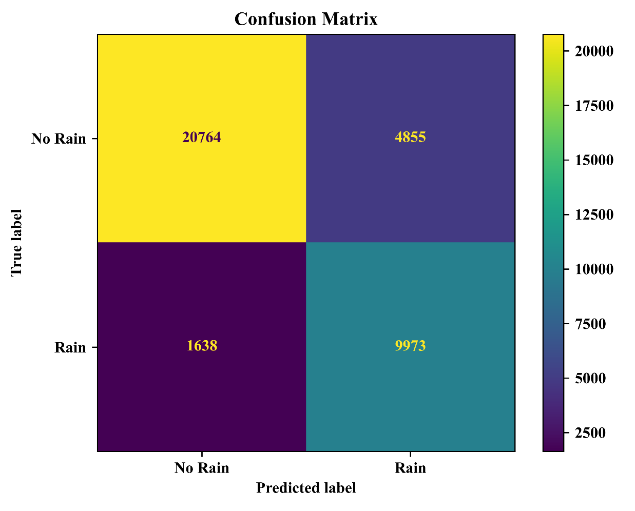
Figure 18: Confusion Matrix of the Logistic Regression Rainfall Occurrence Classifier
The relatively large number of false positives is an important limitation. While the model is effective in minimizing missed rainfall events, users relying on the forecast could receive rainfall warnings for a considerable number of dry days. Therefore, the model's practical usefulness depends on the relative cost of false negatives versus false positives. For agricultural and disaster-management applications where missing a significant rainfall event may be more harmful, the high recall can be considered advantageous.

Overall Interpretation
Overall, the Logistic Regression model provides a useful baseline for next-day rainfall occurrence prediction. The results demonstrate that rainfall occurrence is associated with a combination of humidity, temperature, cloud cover, solar radiation, atmospheric pressure, and temporal weather conditions, rather than a single predictor. The strong contribution of RH2M, T2M, and CLOUD_AMT shown in Figure 17 is also consistent with the meteorological relationships identified during the exploratory analysis.
However, the model's performance also reveals the limitations of a linear classification approach for a complex meteorological process. The relatively high recall, together with moderate precision, suggests that the relationship between weather conditions and rainfall occurrence cannot be fully represented by a simple linear decision boundary. Therefore, the Logistic Regression results provide a useful baseline for comparison with the subsequent Random Forest and XGBoost models. These models can potentially capture nonlinear relationships and interactions among the different meteorological variables that may not be adequately represented by Logistic Regression.
Note: The current model run used one-hot station encoding and a chronological train–test split, with training data up to 2013 and testing data from 2014 onward. These settings are different from the previously defined final project configuration. Therefore, the model settings should be reconciled before the final model performance is reported.

Rainfall Amount Regression and Final Model

Setup
The regression target was defined as the next-day rainfall amount. For each station, the BMD_Rainfall value was shifted forward by one day to create the Target_Rainfall variable. In this way, the weather conditions and lagged features from a given day were used to predict rainfall on the following day. This setup ensures that the task represents a true one-day-ahead forecast rather than same-day nowcasting. From the original 397,902 records, 397,865 remained usable after applying the shift. The 37 excluded records mainly corresponded to the final recorded day for each station, along with a small number of multi-day gap boundaries where a valid next-day rainfall value was unavailable. All models were evaluated using the same fixed chronological split, consisting of 286,109 training records, 49,672 validation records, and 62,084 test records.
A regional spatial feature was also incorporated into the engineered feature set. It represents the average same-day rainfall recorded at the other stations within the same climatic region—Hill/Northeast, Coastal, Central, or Plains/North—while excluding the station being predicted. Since the processed dataset did not contain station coordinates, regional membership was used as a proxy for geographic proximity. Including this feature resulted in a small but consistent improvement across the different model variants.

Model Comparison
Nine approaches were evaluated using the held-out 2012–2016 test period. These included two naive baselines—persistence and seasonal climatology—along with Linear Regression, SARIMA incorporating Fourier terms for annual seasonality, Random Forest, an LSTM using a 10-day lookback window, a back-propagation neural network (BPNN), standard XGBoost, and XGBoost using a Tweedie regression objective. For computational feasibility, the SARIMA model was fitted using data from a representative subset of four stations: Sylhet, Dhaka, Rajshahi, and Barisal. Therefore, its results should be interpreted as a literature-motivated reference rather than a directly comparable estimate for the entire country. The LSTM was also trained using a 60,000-row subsample, with a limited number of training epochs because the model was run on CPU-only hardware.
Table 10: Test-Period Performance of All Regression Models (2012–2016)
Model | RMSE (mm) | MAE (mm) | R²
Naive: Persistence | 20.36 | 7.63 | -0.168
Naive: Seasonal climatology | 17.44 | 8.09 | 0.143
Linear Regression | 15.74 | 8.05 | 0.302
SARIMA (4-station subset) | 15.41 | 6.22 | 0.172
Random Forest | 14.32 | 6.11 | 0.422
LSTM (10-day window) | 14.53 | 6.34 | 0.405
Back-propagation NN (MLP) | 14.40 | 6.04 | 0.416
XGBoost (standard objective) | 14.34 | 6.16 | 0.421
XGBoost (Tweedie objective) | 14.26 | 5.76 | 0.427
Table 10 shows that the tree-based and neural network models produced relatively similar R² values, ranging from 0.405 to 0.422. All of them performed better than Linear Regression (R² = 0.302) and the two naive baselines. The close grouping of these models suggests that, once the naive approaches are excluded, the choice of learning algorithm had a smaller effect on performance than the information captured by the available features. In addition, all of the learned models clearly outperformed the seasonal climatology baseline (R² = 0.143). They also met the project's primary success criterion by achieving lower RMSE and MAE than the naive baseline.
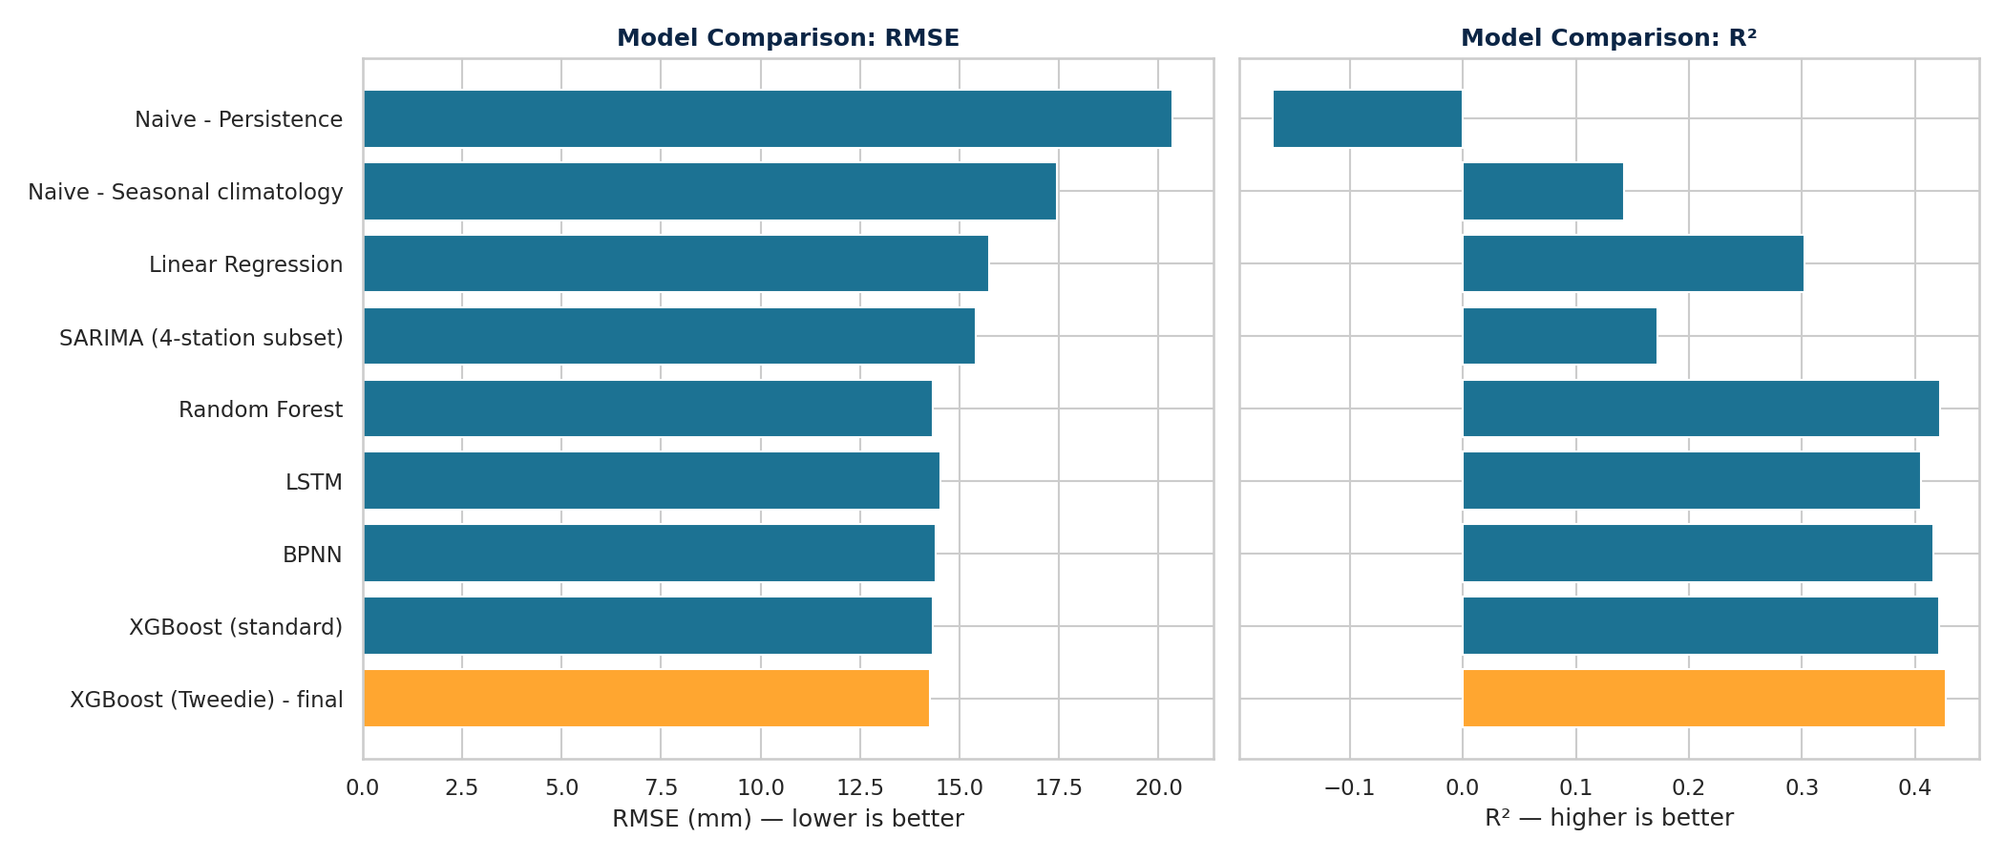
Figure 19: Model Comparison by RMSE and R² on the 2012–2016 Test Period

Rationale for Each Candidate Model
Table 11 summarizes the rationale for including each approach, along with its main strengths and limitations for the dataset used in this study. The comparison suggests that the models differ less in their overall predictive capacity and more in how well their loss functions and input features accommodate the characteristics of daily rainfall data. In particular, the rainfall series is zero-inflated, right-skewed, and recorded at the station level. These characteristics provided the main motivation for selecting the Tweedie objective for the final model.
GARCH models were intentionally excluded from the evaluation as point-forecasting regressors. The main purpose of a GARCH model is to describe the conditional variance, or volatility, of a time series rather than its expected level. Therefore, applying GARCH directly to predict rainfall amounts would not be methodologically appropriate. Such a model could instead be useful for examining changes in rainfall variability over time, but that is beyond the scope of the present project.

Table 11: Rationale, Strengths, and Limitations of Each Candidate Model
Model | Why it was included | Strengths | Limitations in this study
Naive baselines (persistence, seasonal climatology) | Minimum benchmark that any learned model must beat. | No training; fully transparent. | Persistence ignores the fast decay of rainfall autocorrelation (R² = −0.168); climatology ignores current weather (R² = 0.143).
Linear Regression | Interpretable linear benchmark. | Fast; coefficients are directly interpretable. | Cannot represent the threshold-like humidity–rainfall relationship or feature interactions (R² = 0.302).
SARIMA | Standard time-series benchmark used in related Bangladesh studies. | Models seasonality and autocorrelation explicitly. | Univariate, so it ignores the weather features; Gaussian errors suit zero-inflated rainfall poorly; costly to fit per station, so only four stations were used (R² = 0.172).
Random Forest | Robust nonlinear ensemble for tabular data. | Captures interactions; little tuning; resistant to overfitting. | Averaging pulls predictions toward the mean, so extremes are muted; squared-error splitting ignores the zero-inflated shape (R² = 0.422).
LSTM (10-day window) | Learns temporal dependence directly from sequences. | No hand-built lag features required. | Computationally heavy; trained on a 60,000-row subsample on CPU, so likely under-trained; no advantage over tree models (R² = 0.405).
Back-propagation NN (MLP) | Flexible nonlinear learner common in the rainfall literature. | Learns nonlinear feature combinations. | Sensitive to scaling and initialisation; Gaussian loss ignores the zero-inflated target (R² = 0.416).
XGBoost (standard) | Strong gradient-boosted tree baseline for tabular data. | Accurate, regularised, handles interactions. | Squared-error objective does not reflect a non-negative, zero-inflated, right-skewed target (R² = 0.421).
XGBoost (Tweedie), final | Tweedie loss matches the non-negative, zero-inflated, right-skewed shape of daily rainfall. | Lowest RMSE, MAE, and highest R² of all models; one global model for 34 stations; stable for p = 1.1 to 1.7. | Still underestimates extreme events; variance power needs tuning (collapses at p = 1.9); margin over standard XGBoost is small (R² = 0.427).

Final Model: XGBoost with a Tweedie Objective
The best-performing model was XGBoost with a Tweedie regression objective (variance power = 1.3), which achieved an RMSE of 14.26 mm, an MAE of 5.76 mm, and an R² of 0.427 on the 2012–2016 test period. The Tweedie distribution is well suited to non-negative, zero-inflated, and right-skewed targets, which is consistent with the distribution of daily rainfall observed during the exploratory analysis, where 67.84% of the days had no rainfall and the skewness was 5.76. Among the techniques tested in this project, the Tweedie objective was the only one that improved RMSE, MAE, and R² at the same time; the other approaches generally improved one metric while slightly reducing another. The variance power was selected through a sweep from 1.1 to 1.9, as presented in Table 12. Values between 1.1 and 1.7 produced broadly similar results, with R² ranging from 0.420 to 0.427. Although p = 1.5 resulted in a slightly lower MAE (5.74 mm), its RMSE and R² were marginally worse. In contrast, p = 1.9, which moves closer to a Gamma-type assumption with very few zero values, resulted in a substantial decline in performance (R² = 0.273). The performance difference between the Tweedie model and standard XGBoost was relatively small, with standard XGBoost achieving an R² of 0.421. This difference was also comparable to the variation observed across software versions, as repeating the same configuration with different XGBoost versions changed R² by approximately ±0.004. Therefore, the main justification for using the Tweedie objective is not a large improvement in overall accuracy, but its consistently lower MAE and its better alignment with the observed distributional characteristics of the rainfall target.
Table 12: Tweedie Variance-Power Sweep on the 2012–2016 Test Period
Variance power (p) | RMSE (mm) | MAE (mm) | R²
1.1 | 14.291 | 5.839 | 0.4245
1.3 (final) | 14.260 | 5.760 | 0.4270
1.5 | 14.270 | 5.740 | 0.4262
1.7 | 14.343 | 5.884 | 0.4203
1.9 | 16.065 | 6.130 | 0.2728
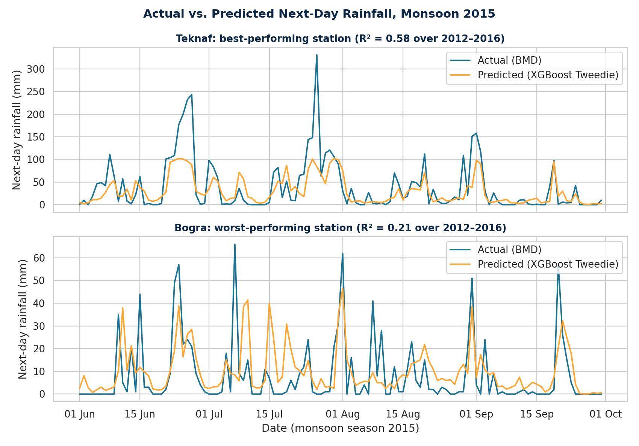
Figure 20: Actual versus Predicted Next-Day Rainfall at the Best-Predicted (Teknaf) and Worst-Predicted (Bogra) Stations, Monsoon 2015
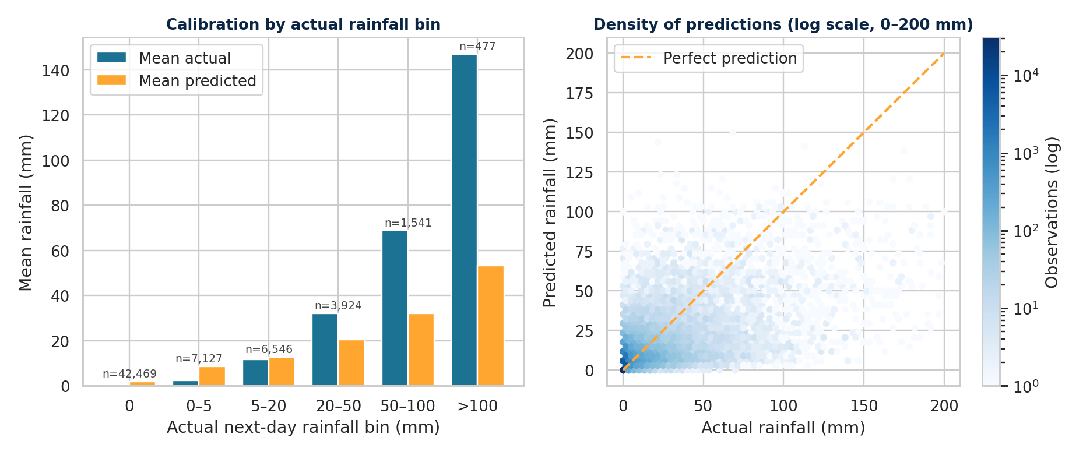
Figure 21: Calibration of Predicted Rainfall by Observed Intensity Bin and Density of Predictions, 2012–2016 Test Period
Figures 20 and 21 provide a closer look at how the final model's predictions compare with the observed rainfall. Figure 20 focuses on the 2015 monsoon season at the station with the highest test-period R² (Teknaf, R² = 0.58) and the station with the lowest (Bogra, R² = 0.21). These two stations were selected based on their test-period R² values from the single national model, rather than by examining individual prediction days.
At Teknaf, the model captures the timing and general rise-and-fall pattern of the major monsoon events reasonably well, but it tends to flatten the peaks. For example, the largest observed rainfall events, which range from about 230 to 330 mm, are predicted at only around 85 to 100 mm. In Bogra, where rainfall occurs in smaller and more localized bursts, the predicted series is smoother. It misses the timing of several observed spikes and also generates some peaks that were not present in the observations, reflecting the lower prediction accuracy observed at inland stations.
Figure 21 presents the same pattern across all 62,084 test observations. The model tends to over-predict dry and very light rainfall days, with a mean prediction of 1.9 mm when no rainfall was observed and 8.7 mm compared with 2.5 mm observed for days receiving 0–5 mm. Predictions are closer to the observed values for the 5–20 mm range, but the model increasingly underestimates rainfall as intensity increases. For example, the mean prediction was 32 mm compared with 69 mm observed for days receiving 50–100 mm, and 53 mm compared with 147 mm for days above 100 mm. This systematic underestimation of the largest events is commonly associated with models fitted to heavy-tailed targets. As a result, the model appears more suitable for estimating typical daily rainfall than for quantifying extreme rainfall events.
The feature-importance analysis identified cloud amount (CLOUD_AMT) as the most influential predictor, with an importance value of 0.35. It was followed by the regional same-day rainfall feature (0.21), downward shortwave radiation (0.13), and dew point (0.07).

Additional Experiments and Robustness Checks
Several further techniques were tested to determine whether the final result could be improved or was sensitive to methodological choices. Each is reported below, including the negative results, since they define the limits of the final model.
- Log-transformed target: Using log(1 + rainfall) as the modelling target improved the MAE to 5.14 mm, but RMSE and R² decreased to 15.38 mm and 0.333, respectively. The lower performance for the larger-rainfall events is mainly due to the systematic underestimation introduced when the log-transformed predictions are converted back to the original rainfall scale. This is a known statistical bias associated with back-transformation rather than an implementation error.
- Two-stage model: A two-stage approach was also tested, in which a rainfall-occurrence classifier first determined whether a day would be rainy, followed by a regression model trained only on rainy days. This approach performed worse than the single-stage Tweedie model across the tested decision thresholds. The best variant achieved an RMSE of 14.54 mm and an R² of 0.404. When the classifier incorrectly identifies a rainy day as dry, the second-stage model cannot recover the event because the prediction is forced to zero, regardless of the actual rainfall amount. These missed events can contribute substantially to squared error, particularly when rainfall is heavy. Lowering the classification threshold did not improve the results because dry days account for 67.84% of the observations, so the additional false alarms introduced by a lower threshold outweighed the benefit of capturing more rainy events.
- Model stacking: A non-negative-least-squares ensemble combining Tweedie-XGBoost, Random Forest, and BPNN produced only a small improvement. It achieved an RMSE of 14.19 mm and an R² of 0.432, compared with 14.21 mm and 0.431 for Tweedie-XGBoost alone in the same run. Approximately 70% of the ensemble weight was assigned to the Tweedie model, indicating that the other models contributed relatively little. Given this marginal improvement, the additional complexity of the ensemble was not justified.
- Per-station models: Separate Tweedie-XGBoost models were trained for each of the 34 stations. Their pooled performance was RMSE = 14.35 mm and R² = 0.420, which did not improve on the single national model. Therefore, training individual models for each station did not provide an accuracy advantage. Station-level R² values varied considerably, from 0.57 at Teknaf to 0.23 at Srimangal, with Coastal stations generally showing better performance than stations in the inland Plains/North region. One possible explanation is that larger-scale, synoptically driven rainfall associated with monsoon and cyclone systems is easier to represent using coarse-grid reanalysis data than smaller, localized convective events. This interpretation is also consistent with the possibility that representativeness error in the NASA POWER grid, which is approximately 55 km per cell, contributes to the model's error ceiling.
- Large-scale climate indices: Adding monthly ENSO (Oceanic Niño Index) and Indian Ocean Dipole (Dipole Mode Index) values did not improve the model. The resulting RMSE was 14.28 mm and R² was 0.425, while both indices ranked near the bottom in feature importance. This is broadly consistent with published findings suggesting that the relationship between ENSO and rainfall in Bangladesh is relatively weak. In this analysis, only the concurrent-month index values were included; lagged climate-index effects were not tested.
- Rainfall source validation: The choice of BMD rainfall rather than NASA POWER precipitation as the target was also evaluated empirically. The final model was retrained using NASA POWER precipitation (PRECTOTCORR) as the target and achieved an R² of 0.272, substantially below the approximately 0.43 obtained using BMD rainfall. The agreement between the two rainfall sources over the test period was moderate (correlation = 0.528), consistent with the original validation range of 0.41–0.53. These results support the use of observed BMD rainfall as the ground-truth target, both from a methodological and empirical perspective.

Summary of Findings
The final regression model achieved an R² of 0.427 for daily, station-level, next-day rainfall across the 34 stations. In the classification track (Section 12), the model achieved an F1-score of 0.759 and a recall of 0.881 for predicting rain occurrence. These results should be considered in the context of the difficulty of the forecasting task.
Higher R² values reported in related studies from Bangladesh generally involve either monthly rainfall aggregation, which reduces much of the day-to-day variability and zero-inflation, or same-day nowcasting using concurrent variables such as visibility and humidity. Some of these variables can themselves be influenced by rainfall, making the prediction task different from a true next-day forecast. When the same-day setup was reproduced using this project's feature set, R² increased only modestly, from approximately 0.43 to 0.454. This suggests that much of the difference from the higher values reported in those studies is related to the forecasting task and dataset scope rather than simply to the modelling approach.

Limitations
- Coarse weather grid: The NASA POWER weather variables are derived from reanalysis data on a grid of approximately 55 km per cell rather than from point observations at individual rain gauges. This spatial mismatch likely limits prediction accuracy, particularly for localized rainfall events in inland areas. The pattern is consistent with the higher per-station R² values observed at Coastal stations compared with inland stations.
- Linear assumption: Logistic Regression may not fully capture the nonlinear and threshold-like relationships identified during the exploratory analysis, particularly those involving humidity.
- False positives: Although the classification model achieved a high rainfall recall of 88.1%, it also produced 8,634 false positives, which reduced its precision to 66.7%.
- Climate indices: The analysis included only concurrent-month ENSO and IOD values. A lagged formulation, such as using the previous season's index to anticipate the upcoming monsoon, was not evaluated and remains an area for future investigation.
- Proxy spatial feature and light tuning: The regional same-day rainfall feature provides only a region-level approximation of spatial relationships because station coordinates were not retained in the processed dataset. Consequently, it does not represent true nearest-neighbour or distance-weighted rainfall. Hyperparameter tuning was also limited to a Tweedie variance-power sweep rather than a full grid or Bayesian search. In addition, the experiments used a single random seed. Repeating the same configuration with different XGBoost versions changed R² by approximately ±0.004, so small differences between the top-performing models should be interpreted cautiously.
- Model complexity: The LSTM was trained using a 60,000-row subsample for a limited number of epochs on CPU-only hardware. Similarly, SARIMA was fitted using data from only four stations. Therefore, neither model represents a fully like-for-like comparison with the national tree-based models.
Overall, the Logistic Regression model presented in Section 12 should be viewed as an initial baseline for predicting next-day rainfall occurrence. The principal predictive result of the project is the final rainfall-amount model presented in Section 13: XGBoost with a Tweedie objective, which achieved an R² of 0.427.
References:
Alom, S., Ahamed, T., & Khan, F. (2025). Machine Learning Modeling for Rainfall Prediction in Bangladesh. Undergraduate Conference on Intelligent Computing and Systems (UCICS), 26-27 February 2025, Varendra University, Rajshahi, Bangladesh
Biplob, M. B., & Haque, M. M. (2024). An Efficient Machine Learning Classification Model for Rainfall Prediction in Bangladesh. In M. S. Arefin, M. S. Kaiser, T. Bhuiyan, N. Dey, & M. Mahmud (Eds.), Proceedings of the 2nd International Conference on Big Data, IoT and Machine Learning (Vol. 867, pp. 169–180). Springer Nature Singapore. https://doi.org/10.1007/978-981-99-8937-9_12

GitHub repository:https://github.com/Habiburnik/Rainfall-Prediction-PGDDS-Batch-09

Annex A. Project Implementation Schedule
Task | W4 | W5 | W6 | W7 | W8 | W9 | W10 | W11 | Responsible
Dataset Collection | ● |  |  |  |  |  |  |  | Tarek
Data Understanding | ● | ● |  |  |  |  |  |  | Tarek & Habib
Data Cleaning |  | ● | ● |  |  |  |  |  | Habib
Exploratory Data Analysis |  | ● | ● |  |  |  |  |  | Habib
Feature Engineering |  |  | ● | ● |  |  |  |  | Habib & Shafiq
Model Development |  |  |  | ● | ● |  |  |  | Shafiq & Sahariar
Model Comparison |  |  |  |  | ● | ● |  |  | Shafiq & Sahariar
Model Evaluation |  |  |  |  |  | ● |  |  | Sahariar
Report Writing |  |  |  |  | ● | ● | ● | ● | All Members
Presentation Preparation |  |  |  |  |  |  | ● | ● | All Members
Final Submission |  |  |  |  |  |  |  | ★ | All Members

